# Clinical Informatics-Modeling Terms, Tools and Their iEHR Use

**Current \*.DOCX is at:** [**http://informatics.mayo.edu/CIMI/index.php/Main\_Page**](http://informatics.mayo.edu/CIMI/index.php/Main_Page)

**\*.EAP is at:** [**https://www.dropbox.com/s/69ca6zhjuxhrcdj/CIMI%20in%20iEHR-CIIF.eap**](https://www.dropbox.com/s/69ca6zhjuxhrcdj/CIMI%20in%20iEHR-CIIF.eap)

[**Stephen.Hufnagel@us.army.mil**](mailto:Stephen.Hufnagel@us.army.mil) **Document Editor**

**27 October 2012, Draft T**



Figure 1 iEHR-CIIF Use of Standards & CIMI Models

“A picture is worth thousands-of-words”



Figure 2 Computationally Independent Models (CIMs), Platform Independent Models (PIMs) & Platform Specific Models (PSMs)

This view has the same content as Figure 1; but, it is reorganized to separate CIMs, PIMs and PSMs.

CIMs, PIMs and PSMs are also known as (aka) Conceptual, Logical and Implementable Models

# ACRONYMS

**AML Archetype Modeling Language UML-Profile**

**BIM Business Information Model**

**BITE Built In Test Environment**

**BJP Business Justification Package**

**BPM Business Process Model**

**CCS Care Coordination Service**

**CDS Clinical Document Architecture**

**CIIF Common Information Interoperability Framework**

**CIMI Clinical Information Model Initiative**

**CLIM Common Logical Information Model**

**CIC Core Information Component (Mind Map)**

**CPOE Computerized Physician Order Entry**

**CSP HL7 Clinical Statement Pattern**

**CTR Clinical-Template Repository**

**CTS Common Terminology Service**

**DAM Domain Analysis Model (DAM)**

**DCM Detailed Clinical Model**

**EHR-S FIM EHR System Function & Information Model**

**ETL Extract, Transform, Load Service**

**FHIM Federal Health Information Model**

**FOC Final Operating Capability**

**HDD Health Data Dictionary**

**IBRM Integrated Business (activity) Reference Model**

**I&FCM Inventory and Funds-Control Management**

**iEHR Integrated Electronic Health Record**

**IOC Initial Operating Capability**

**Iz Immunization**

**JPS JSR 286 Portlet Service**

**JSR Java Specification Request**

**MDHT Model Driven Health Tool**

**NIEM National Information Exchange Model**

**RDF Resource Description Framework**

**RLUS Retrieve, Locate, Update Service**

**RIM Reference Information Model**

**RM Reference Model**

**Rx Pharmacy**

**SCS Structured-Content-Specification**

**VDR Virtual Data Repository**

**VPR Virtual Patient Repository**

**TABLE OF CONTENTS**

[CIMI Informatics-Modeling Terms, Tools and Their iEHR Use 1](#_Toc337972279)

[ACRONYMS 3](#_Toc337972280)

[EXECUTIVE SUMMARY 5](#_Toc337972281)

[NEXT CIMI STEPS (Supporting iEHR): 6](#_Toc337972282)

[REFERENCES 7](#_Toc337972283)

[INTRODUCTION 7](#_Toc337972284)

[CIMI MODELING APPROACH 8](#_Toc337972285)

[NEHTA MODELING APPROACH 9](#_Toc337972286)

[S&I BRANCH ENGAGEMENT PROCESS AND iEHR-CIIF PRODUCTS (Proposed) 11](#_Toc337972287)

[DISCUSSION 19](#_Toc337972288)

[GLOSSARY 25](#_Toc337972289)

[iEHR MODELING ISSUES REQUIRING DECISION 52](#_Toc337972290)

[APPENDIX: Clinical Terminology 59](#_Toc337972291)

[Terminology Glossary 62](#_Toc337972292)

[SNOMED and LOINC Structures 71](#_Toc337972293)

**TABLE OF FIGURES**

[Figure 1 iEHR-CIIF Use of Standards & CIMI Models 1](#_Toc337978458)

[Figure 2 Computationally Independent Models (CIMs), Platform Independent Models (PIMs) & Platform Specific Models (PSMs) 2](#_Toc337978459)

[Figure 3: Archetype Modeling Language (AML) UML-Profile 6](#_Toc337978460)

[Figure 4 S&I Branch Engagement-Process Within iEHR-Capability Acquisition-Lifecycle 11](#_Toc337978461)

[Figure 5 CIIF-Products to Ensure iEHR Semantic-Interoperability 11](#_Toc337978462)

[Figure 6 iEHR Enterprise Architecture Components 16](#_Toc337978463)

[Figure 7 CIIF Design Time Models 16](#_Toc337978464)

[Figure 8 CIIF Run-Time Within iEHR 17](#_Toc337978465)

[Figure 9 Recommended Technical-Architecture Traceability 17](#_Toc337978466)

[Figure 10 Recommended Business-Architecture Traceability 18](#_Toc337978467)

[Figure 11 Recommended Information Architecture’s CIIF Traceability 18](#_Toc337978468)

[Figure 12 Sample CIC: Body Temperature Mind Map from openEHR CKM (Clinical Knowledge Manager) 28](#_Toc337978469)

[Figure 13 Example RDF Graph 50](#_Toc337978470)

[Figure 14 CIIF within a Notional iEHR Context 59](#_Toc337978471)

[Figure 15 Information Model within a Notional iEHR Context 60](#_Toc337978472)

[Figure 16 Service Aware Interoperability Framework (SAIF) Meta-Model 60](#_Toc337978473)

[Figure 17 Information and Terminology Meta-Model 61](#_Toc337978474)

# EXECUTIVE SUMMARY

Figure 1 and Figure 2 show iEHR use of CIMI (Clinical Information Model Initiative) models as containing

* **CIM**s (Computationally Independent Models aka Conceptual Models (**CMs**)), which are the openEHR archetype models (**AM**s) and Mind Maps (**MM**s), **R4C** (Results for Care, Netherlands) Analysis DCMs (Detailed Clinical Models) or **NEHTA** (National E-Health Transition Authority, Australia) AMs and MMs CICs (Core Information Components),
* **PIMs** (Platform Independent Models aka Logical Models (**LM**s)) result when AMs and DCM are composed into “clinically useful” iEHR **CLIM**s (Common Logical Information Model) aka NEHTA-SCSs (Structured Content Specifications), aka Hl7-**CSP**s (Clinical Statement-Patterns)) (e.g., discharge summary).
  + Note that both AM and UML DCM “packages” have CIM and PIM parts.
  + Ideally, published ADL AMs and UML DCMs can go through isosemantic transforms into each other’s representation. Currently, transforms are not 1:1; but rather, they need some extra implementation information added, for DCM 🡪 ADL, or subtracted, for ADL to DCM, transformations.
* **PSM**s (Platform Specific Models aka Implementable Models or physical models) result when CLIMS, SCSs, CSPs or AMs are composed into a Clinical-Template, where UML representations add details for a particular implementation paradigm and ADL representations are constrained to a particular implementation paradigm.
* As an example, NEHTA creates CIC MMs and AMs, using their copy of the openEHR [Clinical Knowledge Manager (CKM)](http://www.openehr.org/knowledge) web portal for the reviewing, publication and governance of openEHR archetypes. Then, they transform the archetypes into DCMs; and, they group the DCMs into SCSs; which, they transform into implementable Clinical-Templates, such as CDA documents or HL7 V3 messages.
  + NEHTA purposefully define their DCMs as PIMs aka logical information models, without implementation details.
  + NEHTA SCSs are use-case specific logical models that contain a collection of DCMs that are selected based on specific use-case requirements.
* On the surface the above steps seem straight forward; but in reality, ADL and UML model representations are based on radically different paradigms and models; and, they are created with entirely different processes; because, ADL archetype constraint-hierarchies are subtractive, while, UML class inheritance-hierarchies are additive; but be aware that, UML models are not always additive.  You can create a profile which separates substitution from inheritance, and use OCL (Object Constraint Language) to model, as you might in ADL; because, OCL is a formal constraint and query language.  Making simple UML/OCL and RM/ADL contrasts may be a false dichotomy. An ADL RM contains implementation details, while an UML RM contains a super-set of classes. They are neither synonyms nor antonyms; in our situation, the differences are subtle.
* Archetype advocates may argue that DCMs, without a reference model, can be inconsistent across organizations; while, DCM advocates may argue that archetypes have implementation details in their “PIMs.”
  + This implies that, the openEHR and CIMI Reference Models (RMs) start with the universe of possible classes (and data elements (is this true for archetype data elements?)); then, they are constrained-down to meet specific clinical domain requirements; while,
  + DCMs start with nothing or with subsets of classes from the FHIM or HL7 RIM; then, the class attributes are augmented by domain-specific and implementation-paradigm inheritance.
* CIMI productivity and reusability will be limited till its partners converge on consistent informatics terms and model representations, processes, governance, configuration management, system-of-record repository, and “isosemantic” model transformations. The proposed OMG **AML** (Archetype Modeling Language) profile for UML, which includes ADL like features, to constrain models, is intended to help catalyze sharing of isosemantically equivalent ADL and UML models. The objective of OMG’s AML UML profile is to to support the CIMI modeling requirements.
  + AML supports model-to-model transformations (ADL or CDL archetypes to UML and vice-a-versa)
  + AML UML specifications support MDHT and commercial tool venders to include the AML UML-Profile
  + OMG has already created a profile to support NIEM called NIEM UML
    - NIEM UML is not sufficient to create healthcare models; but, AML UML will subsume NIEM UML
    - Models based upon AML can be transformed into other modeling paradigms and structures
      * AML to ADL, CDL, CDA, NIEM, XML, JSON, IDL, etc.
    - Other modeling paradigms can be transformed into a subset of AML models
      * AML includes ADL, CDL, CDA, NIEM constructs

This paper will be periodically updated to facilitate understanding-of-differences as we harmonize CIMI processes and products required to efficiently support the CIMI goal of international reusable models.

Figure : Archetype Modeling Language (AML) UML-Profile

AML Profile Requirements-Specification Capability exceeds the capabilities of ADL, CDA & NIEM; noting that

Transformation among models and implementation of models are done separately (e.g., by MDHT)

## NEXT CIMI STEPS (Supporting iEHR):

1. Laboratory Report (simple Single value lab results with LOINC and SNOMED CT codes, which may be grouped into a panel; but not, Results with deeply nested hierarchy of values or “Anatomic Pathology” reports, which includes microscopic evaluation of tissue, Cultures, for January HL7 FHIR “connect-a-thon”, with the following POC:
   * Intermountain Health POCs: Stan Huff
   * FHA POC: Doug Fridsma

Immunization Management needs of US iEHR, including Immunization Administration event, Adults and pediatrics, adverse reaction event, immunization substance, manufacturer of the immunization, and documentation of contraindications (or reason not to administer).

* + VA POCs: Mike Lincoln supported by Galen Mulroney
  + DOD POCs: Nancy Orvis supported by Kevin Coonan and Steve Hufnagel

## REFERENCES

1. **\*.EAP is at:** <https://www.dropbox.com/s/69ca6zhjuxhrcdj/CIMI%20in%20iEHR-CIIF.eap>
2. The **S&I Framework** (US HHS ONC sponsored Standards and Interoperability Framework) collaborative-community reference-material link provides examples of Clinical Information Models that can be potentially leveraged and re-used as applicable for the S&I Lab Results Initiative. <http://wiki.siframework.org/Clinical+Information+Models+for+LRI>
3. **US DOD-VA iEHR** Representative artifacts are publically available at: [www.tricare.mil/iEHR](http://www.tricare.mil/iEHR) then click on Vendor Information in the left column.
4. **GE and Intermountain Healthcare** Clinical Element Models have been developed to help move the industry towards computable models. can be browsed at <http://intermountainhealthcare.org/CEM/Pages/LicenseAgreement.aspx> after agreeing to the license agreement. The CEDatatypes and CEReference manuals serve as background information to understand these models.
5. **openEHR** is the canonical reference for archetypes. Their website has extensive descriptive information at <http://www.openehr.org/home.html>. Most information can be easily found by searching “openEHR” plus the CIMI Term of interest.
6. **NEHTA**, Australia has published information on their work at <http://www.nehta.gov.au/connecting-australia/terminology-and-information/detailed-clinical-models> Most information can be easily found by searching “NEHTA” plus the CIMI Term of interest.
7. **Results4Care (R4C)**, Netherlands has published DCM info at <http://results4care.wikispaces.com/> Most information can be easily found by searching “Results4care” plus the CIMI Term of interest.

# INTRODUCTION

This document is intended to enlighten interested **CIMI** (Clinical Information Model Initiative) and iEHR stakeholders and to harmonize terms, models, representations, tools and approaches among CIMI participants. This document also describes the proposed CIMI use within the Australian NEHTA, Open EHR and US iEHR programs. This document is also intended to be source materials for the iEHR Data Management Plan (DMP). Figure 1 iEHR-CIIF Use (above) is the topic of this paper.

Figure 2 contains the same model, reorganized into Computationally Independent Models (CIMs) aka conceptual models, Platform Independent Models (PIMs) aka logical models and Platform Specific Models (PSMs) aka implementable models. The paper’s body focuses on data models and the paper’s appendix focuses on terminology models. This paper is written in the context of the US Department of Defense and Department-of-Veteran-Affairs iEHR (integrated EHR). The iEHR IPO (Interagency Program Office) S&I (Standards and Interoperability) Branch and its CIIF (Common Information and Interoperability Framework) mission / primary-requirement is to maintain syntactic and semantic interoperability of clinical data; including harmonizing terminology for information exchanges among clinical components and data collected over various times and from various locations. Figure 6 iEHR Enterprise Architecture Components (below) implies that the iEHR Business Architecture (**BA**) defines requirements for the iEHR’s Information Architecture (**IA**) CIIF design-time models; and, the figure also implies that the BA defines iEHR’s implementation Technology Architecture (**TA**) Interoperability requirements, supported by CIIF run-time services. Figure 9, Figure 10, and Figure 11 show the traceability relationships across the BA, IA and TA components.

# CIMI MODELING APPROACH

CIMI organizations use different methodologies, informatics terms and models ((**AM**s) archetype models, **CIC** (Core Information Concept), **DCM** (Detailed Clinical Model), Structured Content Specifications (SCS) templates, CLIMs (Logical Information Models) and Reference Models (**RM**s such as the HL7 RIM, ISO 13606, CIMI RM, US FHA FHIM)), model representations (ADL, UML, CDL, etc.) and tools to get to reusable archetype, DCM or template models, which can be optimized as CLIM implementation design specifications or MDHT design automation. The OMG is developing a CIMI UML profile specification to make ADL and UML “isosemantic” (aka semantic isomorphic) representations. Following are the CIMI fundamentals:

* CIMI Foundations (available at <http://informatics.mayo.edu/CIMI/index.php/Main_Page> )
  1. CIMI Reference Model
  2. Archetype Object Model
  3. CIMI Modelling Patterns
  4. CIMI Style Guide
* Generic CIMI Modelling Approach
  1. Analyse clinical models submitted (with value sets)
  2. Identify maximal set of data elements
  3. Remove ‘out of scope’ data elements (Style Guide)
  4. Select appropriate CIMI Modelling Patterns (Style Guide)
  5. Define CIMI model ( CIC Mind Map, ADL, UML)
  6. Add Terminology bindings
     + Meaning (nodes, node relationships)
     + Value sets (maximal set from submitted models)
  7. Add Example Model Data Instances
  8. Technical Validation
     + ADL, UML
  9. Clinical Validation / Review
  10. Confirm mappings from submitted models

# NEHTA MODELING APPROACH

**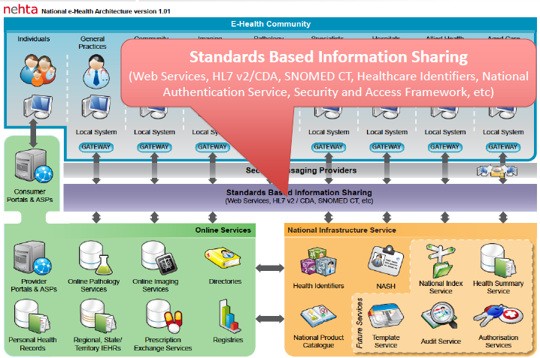**

NEHTA, Australia DCM priorities (<http://www.nehta.gov.au/> ) are the following core clinical concepts:

* Medications & Immunisations, Adverse Reactions, Medical History (including Problems and Diagnosis)
* Lifestyle Risk Factors, Family History, Social History
* Laboratory and pathology tests (including general laboratory, microbiology and anatomical pathology)
* Requested Services, Diagnostic Imaging, Clinical Synopsis, Procedure, Reason for encounter

NEHTA, Australia DCM processes (<http://www.nehta.gov.au/> ) generally follow these steps:

1. The collaboration process is in the NEHTA Clinical Knowledge Manager (CKM)[[1]](#footnote-1) web site which defines

* scenarios of use,
* requirements for DCMs and
* Core Information Components (**CIC**s), as mind maps

1. The CICs will result in a library of archetypes (initially *open*EHR archetypes)
   * based upon requirements identified by Australian clinicians and other health domain experts, and drawing from comparable work overseas.
2. Archetypes will be transformed into platform and reference model agnostic DCM models (based upon ISO 11179).
   * Initially, the DCMs (Detailed Clinical Models) will be available only in human-readable PDF format.
   * In the medium term we intend to make DCMs available in a number of machine-readable formats, and we will consult the community to determine what formats are required.
3. DCMs are composed into template SCSs for clinically meaningful artefacts, such as discharge notes.
4. SCSs are developed into CDA Implementation Guides (IGs).
5. DCMs, SCSs and IGs will be uploaded to the National Information Component Library that NEHTA is building.

*“NEHTA DCMs are logical models derived from our openEHR archetypes that we developed. After the archetypes are “signed off” by the reviewing clinicians and the editorial panel, they undergo transformation processes which include removing some openEHR reference model constructs (e.g. those required for EHR record keeping and tracking) that are not relevant to our requirements, and make explicit some openEHR reference model constructs that are implicit, e.g. participants and participations. The logical models are then transformed into platform specific isosemantic models, e.g. the HL7 v2 segments and HL7 v3 classes. After the transform, we call them EDCM (exchangeable DCMs).”* [Stephen Chu, 23-Sep-12]

NEHTA RECOMMENDED MODEL QUALITY CRITERIA

CIMI models will be:

* Able to satisfy the URU principles – that is they will be
  + **U**nderstandable (cohesive and coherently expressed)
  + **R**eliable and reusable (consistency)
  + **U**seful (fit for purpose)
  + **U**p-to-date (currency)
* Clinically accurate
* Clinically valid
* Evidence based
* Adequate to express required clinical statements
* Able to maintain contextual integrity (when transformed into isosemantic models)
* Able to maintain semantic fidelity (when transformed into isosemantic models)
* Clear and precise, minimizing the potential for:
  + Misinterpretation and
  + Misuse or inconsistency in use
* With low complexity (suitable for easy implementation and avoid cognitive overload of users)

# US–iEHR S&I BRANCH ENGAGEMENT PROCESS AND PRODUCTS (Proposed)



Figure 4 S&I Branch Engagement-Process Within Each Capability’s Lifecycle



Figure 5 Interoperability Specification (IS) Modeling Artifacts

The goal of US iEHR Inter-Agency Program Office (**IPO**) Standards-and-Interoperability **(S&I**) Branch and its **CIIF** (Common Information Interoperability Framework) is to ensure semantic interoperability of Information Exchanges (**IEs**). The S&I Branch builds upon and complements the Business Architecture (**BA**), for data which may otherwise vary across time-and-space; where, the CIIF *design-time* information-models and terminology-models respectively specify IE syntax-and-semantics and the CIIF *run-time* services normalize IE syntax-and-semantics. S&I Branch follows a Model-Driven-Architecture (**MDA**) and Model-Driven-Design (**MDD**) approach to generate iEHR *design-time* Interoperability-Specifications (**IS**s) and *run-time* Clinical-Template-Repository (**CTR**) Schemas, Common-Terminology-Service (**CTS**) mappings, and Built-In-Test-Environment (**BITE**) Schematron. The semantic interoperability objectives are to produce clear, complete, concise, correct, consistent and easy-to-use CTR-schemas, CTS-mappings and BITE-Schematron. A Joint Information Exchange Tool (**IE Tool**) and **TSP** (Technical Standards Profile) are used to document the IEs and their associated IS standards.

Representative models are available at [www.tricare.mil/iEHR](http://www.tricare.mil/iEHR) --> click on Vendor Information in the left column.

Federal Health Information Model (**FHIM**) priorities are the following information-and-terminology domains:

* Adverse Event Reporting, Allergies, Audiology and Speech Pathology, Behavioural Health, Blood Bank, Care Plan, Clinical Decision Support, Clinical Document, Compensation and Pension Exam, Consultation Request, Dental, Dietetics, Encounter, Enrolment / Eligibility / Coordination of Benefits, Event Capture, Health Factors, Home-based Primary Care, Imaging, Immunization and Skin Test, Lab, Mental Health, Oncology Registry, Orders, Patient Education, Patient Journaling, Person Demographics, Pharmacy, Problem List, Prosthetics, Provider, Radiology, Security and Privacy, Social Work, Spinal Cord Injury, Surgery, VA/DoD Eligibility, Vital Signs, Women’s Health; plus,
  + Common, which contains concepts that are used by more than one domain. These concepts are grouped here primarily for convenience, but also to limit dependencies between packages, and
  + Data types, which contains classes that can be referenced as data types by attributes of other FHIM classes. While any class can be used as the type of an attribute in UML, the FHIM modelling style limits data-types to UML primitive types or those classes in the Data-types package; where, all other references between FHIM classes are modelled as associations, not as attributes.

**C-IPTs** (Capability Integrated Product Teams) develop an integrated Business Justification Package (**iBJP**) for each of the approximately fifty-five iEHR capabilities. The iBJP contains:

1. **iBPR** (integrated Business Process Models Report) with one-or-more Business Process Models[[2]](#footnote-2) (**BPMs**) and/or Use Cases, which identify Normalized Business Objects (**NBOs**). NBOs become candidate IEs, which have associated Interoperability Specifications (**ISs**).
2. **iIMR** (integrated Information Model Report) with one-or-more Business Information Models[[3]](#footnote-3) (**BIMs**) and data dictionary,
3. **iBRD** (integrated Business Requirements Document),
4. **iBPR** (integrated Business Process Reengineering) Checklist,
5. **iASR** (integrated Architecture Specification Report); where, the capability’s Business Architecture (**BA**) artifacts must be traceable to both the DOD and VA Enterprise Architectures (**EAs**), via the iBRM (integrated Business Reference Model aka DODAF OV-5 Operational Activity Model); including, iBRM mapped to EHR-S FM (e.g., DODAF **SV-5**: Operational-Activity to Systems-Function Matrix)
6. **IS** (Interoperability Specification) Document for IEs is created by the S&I Branch. **🡨 NEW (proposed)**

In support of each capability’s lifecycle, the S&I Branch informatics-staff execute the steps in Figure 4; and, they develop the IS modelling artefacts in Figure 5; that is,

1. As each C-IPT develops the initial **BJP** (Business Justification Package) content for a capability,
   1. the BA Team develops initial content for the BJP’s iBPP, iIMR, , iBRD, iBPR checklist, iASR ; and,
   2. The S&I Team develops initial BJP’s IS content; and,
   3. The S&I team develops a Capability Approach Proposal / Plan (**CAP**), which
      1. Identifies reusable information & terminology models (e.g., CLIM, FHIM, SNOMED CT).
      2. Identifies applicable standards, regulations (e.g., HIPAA), policies and rules.
      3. Documents the capability’s candidate IEs, traceable to the BA Team’s BPM NBOs; where,
         1. the S&I team manages IEs in the DOD-VA Joint IE Tool; and,
         2. the IE Tool links IEs to standards; and,
         3. standards are managed in the DOD-VA Joint **TSP** (Technical Standards Profile).
      4. Identifies or creates candidate / analysis / initial **SCSs** (Structured Content Specifications) based on
         1. the BIM, BPM NBOs, CLIM, FHIM and IE requirements.
         2. SCSs specify IE content (e.g., consult summaries or diagnostic test reports); where,
            1. IE content will ultimately become documents, services and/or messages depending on
            2. regulations, policies, and business rules.
      5. Identifies or creates candidate / analysis / initial **DCMs** (Detailed Clinical Models); where,
         1. DCMs represent core clinical concepts, such as pulse or blood pressure; where,
         2. DCMs include associated metadata, such as patient position, recent activity, etc.; where,
         3. DCMs may optionally be represented as CIC (Core Information Concept) Mind Maps.
      6. Publishes candidate DCMs, optionally represented as CICs, and candidate SCSs on a
         1. Social-media “swarming” web-site, for 4-to-6 months of stakeholder review-and-update.
      7. Define initial Interoperability Specifications (**ISs**) for IEs, as SCS; where,
         1. The HL7 Service Aware Interoperability Framework (SAIF) defines the IS; and,
         2. SAIF’s Enterprise Compliance and Conformance Framework (ECCF) organizes the IS; where,
         3. SCS ISs are constrained by Regulations (e.g., HIPAA, CLIA), policies and business rules.
2. In preparation to finalize[[4]](#footnote-4) the BJP and in anticipation of an **RFP** (Request for Proposals) to industry,
   1. S&I Branch formalizes the DCMs, optionally represented as CIC mind maps, into
      1. fully-qualified context-specific DCMs, represented in Unified Modelling Language (UML); where,
         1. the DCMs are bound to reference terminology models; and,
      2. the DCMs are integrated into logical **SCSs**; where,
         1. the SCSs are bound to terminology value sets; and,
         2. the SCSs are traceable to the capability’s requirements, BIM and BPM NBOs.
3. In the final BJP, the S&I Branch IS documents outward-facing IEs (i.e., BPM NBOs); where,
   1. Outward-facing standards-based IEs are with
      1. External partners
      2. External and/or federated sub-systems; such as, Lab, Rad or Pharm. ancillary services.
   2. fully-specified SCSs are the IS Document’s logical models.
4. For consistency, new-or-updated DCMs and SCSs are harmonized with the
   1. S&I Branch **CLIM** (Common Logical Information Model) and
   2. FHA **FHIM** (Federal Health Information Model).
   3. the DCMs, CLIM and FHIM are managed in the IBM RSA (Rational Software Architect) tool as a composite “Über” (overarching) model across capabilities and medical domains; where,
      1. the RSA tool generates a consistent set of SCS views for the iEHR capabilities’ ISs.
5. In support of an acquisition-or-development and deployment,
   1. The C-IPT supports the following Capability Lifecycle processes
      1. **RFIs** (Request for Information),
      2. **RFPs** (Request for Proposals),
      3. Design Reviews,
      4. Test and Certification.
   2. The S&I Team
      1. Manages RLUS, CTS, CTR, BITE, ETL-IE API Interoperability Specifications
      2. Uses the Eclipse Platform, IHTSDO workbench, RSA tool to bind
         1. DCMs with terminology models and
         2. SCSs with terminology value-sets; and,
      3. Uses the **MDHT** (Model Driven Health Tools) to bind the SCSs to implementation-models; such as,
         1. JAVA, CDA, HL7 V3; thereby,
         2. transforming the SCSs into Implementation Guides (**IGs**) containing
            1. Implementable Clinical-Template Schemas,
            2. **BITE** (Built In Test Environment) Schematron; so that,
            3. The schemas and Schematron can become the *run-time*

BITE, CTR, ETL-IE content; in accordance with,

Regulations, Policies, and Business Rules.

1. In support of the iEHR Enterprise Architecture,
   1. The BA Team manages
      1. The iBIM, aka iEHR DODAF DIV-1 Conceptual Information Model
      2. the iBPMs, aka iEHR DODAF OV-6c Conceptual Event Trace process models
   2. The S&I Team manages
      1. The CLIM, aka iEHR DODAF DIV-2 Logical Information Model
      2. The set-of Clinical Templates, aka DODAF DIV-3 Physical Information Models
2. To govern and Configuration Manage CIC, DCM, SCS, CLIM models and CTS, CTR, BITE, ETL-ES content
   1. CIIF development versions of the Eclipse, IHTSDO, RSA Workbench tool databases are on CollabNet at <https://www.aceworkspace.net/sf/projects/veterans_administration_project/>. Catherine Hoang, VA CollabNet site administrator phone is 352-219-7976 and e-mail is [Catherine.Hoang2@va.gov](mailto:Catherine.Hoang2@va.gov).
   2. CM (Configuration Management) model versions, for peer review and vender access, are on
      1. FHA S&I Framework wiki at <http://wiki.siframework.org/> and/or
      2. iEHR [www.tricare.mil/iEHR](http://www.tricare.mil/iEHR) and/or
      3. <http://www.openhealthtools.org/> (Open Health Tools (**OHT**)) and/or
      4. [www.OSEHRA.org](http://www.OSEHRA.org) VistA Open Source custodial agent and/or
      5. [www.iEHR.wikispaces.com](http://www.iEHR.wikispaces.com) managed by S&I Branch.
   3. For **IOC** (Initial Operating Capability), the 3M Open HDD (Healthcare Data Dictionary, [www.HDDaccess.com](http://cts.businesswire.com/ct/CT?id=smartlink&url=http%3A%2F%2Fwww.HDDaccess.com&esheet=50279495&lan=en-US&anchor=www.HDDaccess.com&index=2&md5=403d436352737a22fb3b9630625edb05) ) is the CTS (Common Terminology Service); where,
      1. HDD has a CTS1 API; and reportedly,
      2. 3M is working on a CTS2 API; where,
      3. The HDD manages concept model, data dictionary and concept-terminology mappings.
3. **FHA** (Federal Health Architecture) publish, to encourage vender uptake and National use,
   1. DCMs (optionally represented as CIC mind maps),
   2. logical SCSs and FHIM,
   3. IGs and / or implementable Clinical Templates.
4. S&I Branch staff will work with **SDOs** (Standards Development Organizations), to standardize
   1. DCMs (optionally represented as CIC mind maps),
   2. SCSs and FHIM,
   3. IGs and / or implementable Clinical Templates.

**DELIVERABLES**

**C-IPT / BJP:** Capability IEs and their ISs, traceable to BIM, BPM and Functional Requirements.

**PMs**: Interoperability Specifications and/or content for RLUS, CTR, CTS, BITE, ETL-IE Services.

**HARB**: The following BA & S&I models are applicable to the iEHR Enterprise Architecture

* + - IE Tool updates (e.g., DODAF **OV-3** Information Exchange Matrix),
    - TSP updates (e.g., DODAF **StdV-1** Standards Profile),
    - iBIM (e.g., DODAF **DIV-1** Conceptual Information Model)
    - CLIM (e.g., DODAF **DIV-2** Logical Information Model)
    - Clinical-Templates (e.g., DODAF **DIV-3** Physical Information Models)
    - iBPM (e.g., DODAF **OV-6c** Event Trace (process models)
    - **iASR** (integrated Architecture Specification Report); including, iBRM mapped to EHR-S FM (e.g., DODAF **SV-5**: Operational-Activity to Systems-Function Matrix)

**S&I / FHA:** DCMs (optionally represented as CICs), SCSs, CLIM and Clinical-Templates are governed, configuration managed and published on a public web-site.

**REFERENCE:** For an up-to-date glossary, models and discussions of terms used in this section,

See the current version of **“***Clinical Informatics-Modeling Terms, Tools and Their iEHR Use*”

Available at[**http://informatics.mayo.edu/CIMI/index.php/Main\_Page**](http://informatics.mayo.edu/CIMI/index.php/Main_Page) under Quick Links

Figure 9, Figure 10, and Figure 11 show the traceability that must exist among the Business architecture, technical architecture and CIIF information and terminology models.



Figure 6 iEHR Enterprise Architecture Components



Figure 7 CIIF Design Time Models



Figure 8 CIIF Run-Time Within iEHR

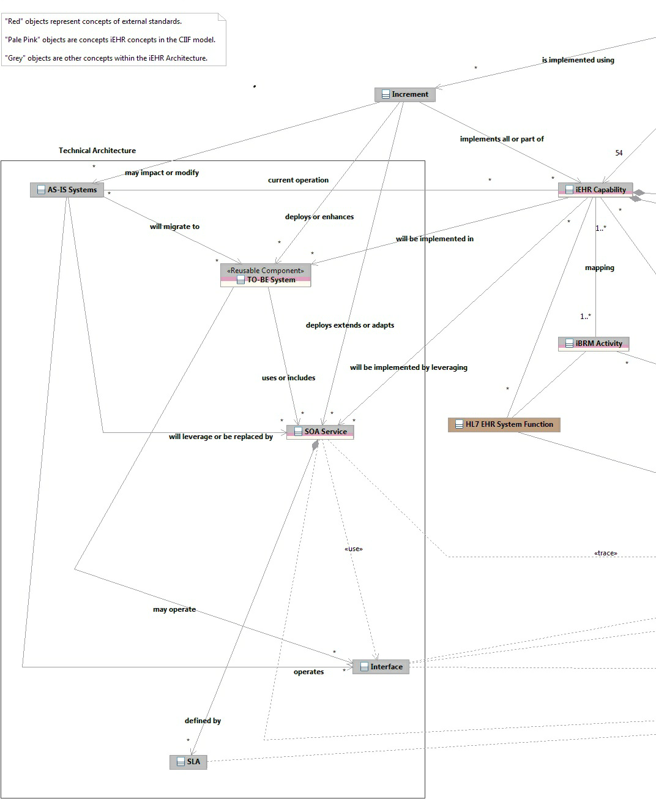

Figure 9 Recommended Technical-Architecture Traceability

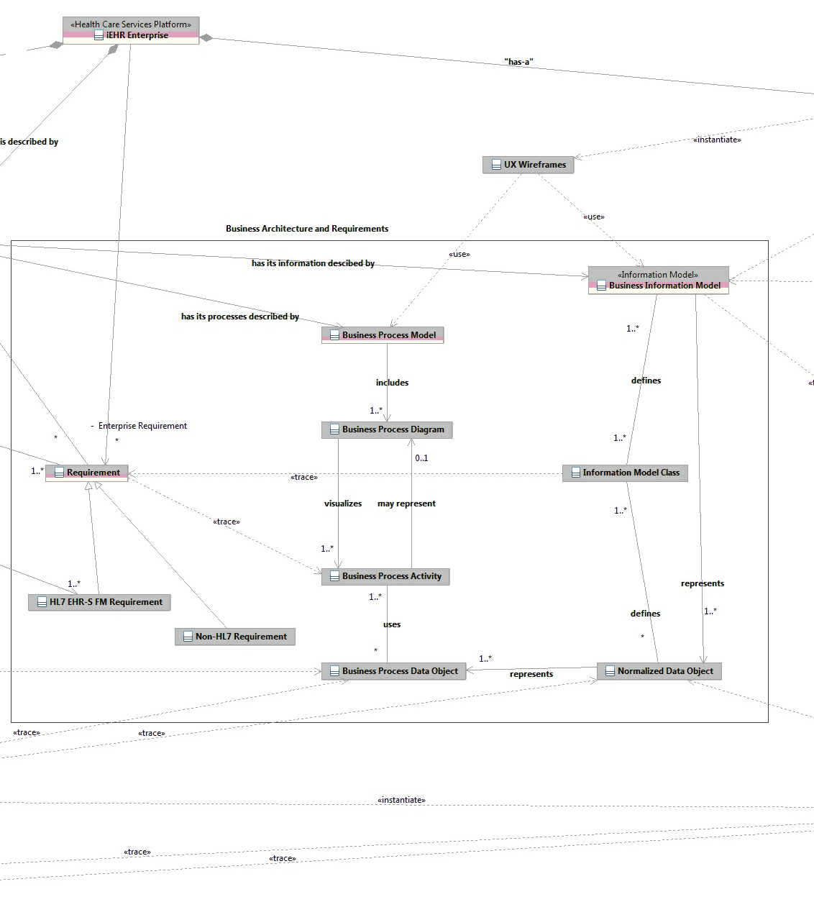

Figure 10 Recommended Business-Architecture Traceability

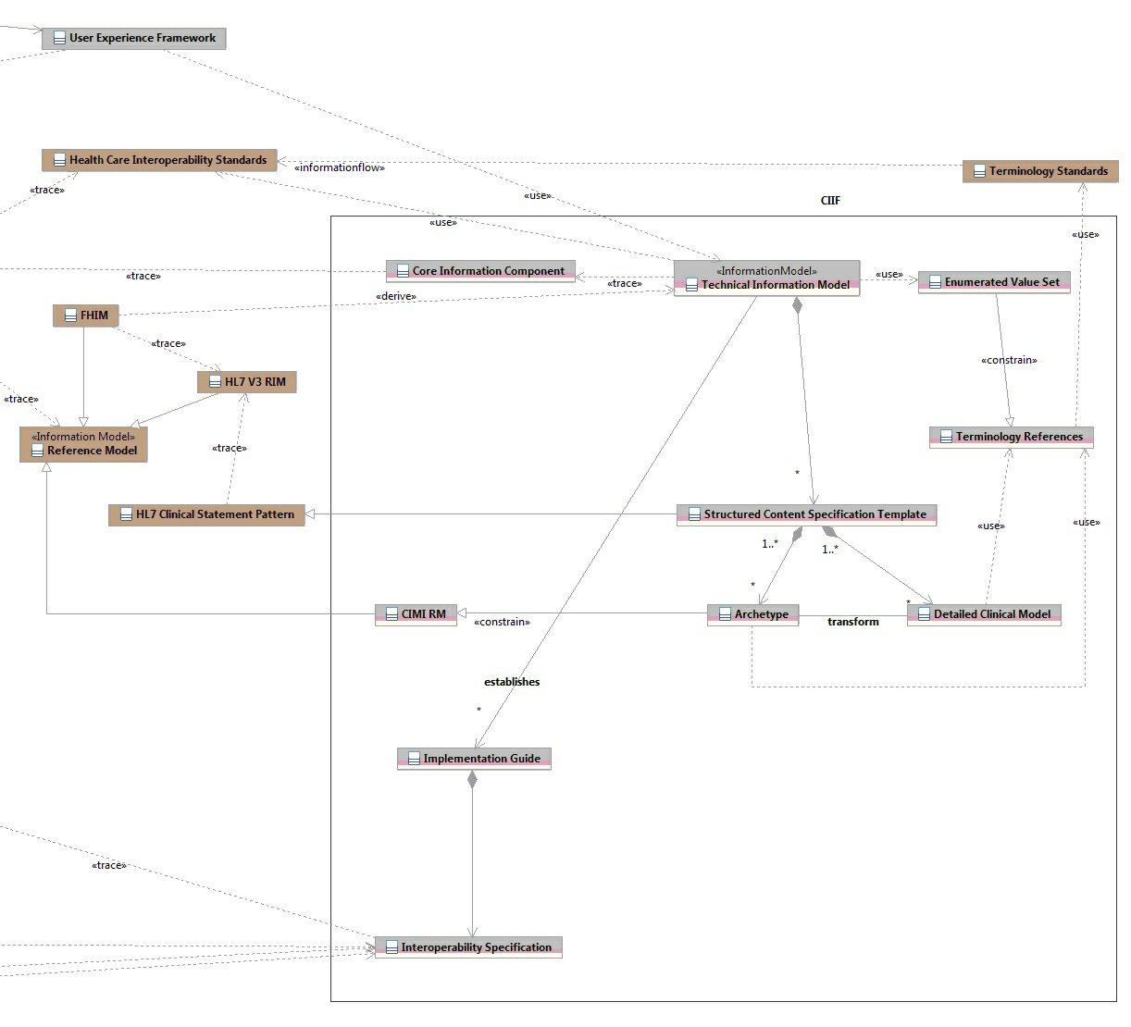

Figure 11 Recommended Information Architecture’s CIIF Traceability

# DISCUSSION

**[Thomas Beale, 20120923]:** I would initially suggest that what is inside the (Figure 1) center box needs to be clarified. The difficulty in these exercises is that everything is a 'model', so we need to be clear about what kinds of models we have. I don't think the one diagram can try to convey information about both realm-specific 'models' and general model categories. Therefore I think it would help to first develop a diagram that only includes general model types, and then have a separate diagram that includes the realm specific stuff (marked in red, also some aspects of what you are assuming is in MDHT). Additionally, I think a lot of published models - e.g. standards 'models' are not generally realm-specific, but nevertheless need to be considered as specific exemplars of various model categories.

**[William Goosen, 20120923]:** Except for your suggestions to separate this into different models, which I agree with, the other suggestions and rename suggestions make things more complex than necessary.

* And, we do have proper sorting things out means in ISO 11179 conceptual, logical, physical.
* And the generic component model, discussed by Blobel et all.

Further, I think the top down approach from an RM to specific archetypes is too much funneling of the clinical world into one specific world view. That is way I not only agree to using; but, insist on using UML, which is RM agnostic, as alternative.

* DCM are definitely not as you describe them: use case specific. They are maximum data set based models against specific clinical concepts and knowledge. Using DCM in a specific RM and or RIM requires the specifics to be added. Implementation requires that use case specific constraints be applied, selections made, codes chosen from the synonyms etc. Basically, following the OpenEhr template approach; but, with the exception of combining different archetypes. That same approach can be followed in DCM compositions; where, 1-n DCMs can be combined to meet user needs.

**[Thomas Beale, 20120923]:** these categories are levels of abstraction in the development of a database schema, not different types of models. They don't really help us that much on this point. The first thing is to identify different categories of models - i.e. models that do different types of jobs. So far we have the following:

* (underlying) **information model**, aka reference information model - the model from whose classes logical instances are created
* **library of definitions of content data points & groups** (e.g. define the data points of vital signs etc) - ADL archetypes
* models of **use-case-specific data sets** (e.g. specify data set of radiology report, discharge summary etc), which use the library definitions above - ADL templates
* **operational form of a data set model**, generated by compilation of a data set specification (above)
* **downstream forms** of data set models, including APIs (facades), XSDs, message definitions and so on.
* [Amended] **DCM** - an informal/semi-formal description of content data points / data groups relating to a clinical topic - i.e. a precursor to an archetype.

These categories of model all have distinct roles and are neither interchangeable, nor just different abstract levels of the same thing, with the possible exception of a 'DCM' being a conceptual expression of an archetype definition (I wrongly had this as a template pre-cursor - now amended according to your reply). I have deliberately not tried to choose definitive names for these model types.

The UML world does not currently know about these categories, because it doesn't do multi-level modeling. That's the whole point of the AML (Archetype Modeling Language) effort in OMG. So today's UML can't really help us here.

* Based on what I now know from the MDHT work, this can certainly change - but you have to realize that MDHT makes radical departures from textbook UML practices to do it (and that's a good thing). Where levels of abstraction come in is going down the specialization hierarchies. For example, you can define a template for 'standard discharge summary' - maybe even internationally. Then this can be specialized by NL, SE, UK, AU, US, etc etc to make some national template. This can be further specialized to make more local variants, and also specialty-specific variants e.g. ICU discharge. To achieve all of this usually requires (we know by experience) the creation of more general archetypes (preceded by DCMs if you want) which are specialized down their own inheritance lineages to be more specific.
* I don't disagree that this is a useful and important thing to depict, just that it probably can't be done on the same diagram as the above - the levels of abstraction exist within some of the model categories in the above list. I agree it's not trivial. But this is the kind of modeling we need in health informatics if we are going to actually get away from manually building *ad hoc* XML for every new requirement. Doing it properly requires clear definitions and description of the modeling environment/ecosystem. Otherwise we don't know what we are talking about.

**[William Goosen, 20120924]** We are getting closer…. Good again to have some progress. However, every time I read your material it is as if something relevant for a clinical modeler like me is left out. Amendments in your original text, below, are directly underneath. The reorganization of your listing is according to my view of the world, which sometimes has a different mix of the colors of Rubik’s cube than you have. But we agree on the colors we see and we agree that the perspectives can go around. I suggest the following additions to Toms sorting out the models. Perhaps that also further clarifies Stephen H’s questions.

**[Thomas Beale, 20120924]:** well remember we were working originally from Steve's depiction of the iEHR, which is a software engineering framework in which modeling is done by domain specialists. I personally would create a couple more diagrams to capture all the dimensions, and at least one of those would include the clinical model ecosystem.

* **[Thomas Beale, 20120923]: - Conceptual model** – any kind of description or ontology of the healthcare system or part thereof (Refer to Blobel’s work on this, who is following Barry Barber and the rest of the Buffalo ontology team). In my opinion there are micro ontologies: e.g. all the knowledge about the Apgar score and its clinical use is a quite fixed micro domain in perinatology. For more insight in how this works please look at:
  + **[William Goosen, 20120924]:** Bowker, Geoffrey C.; Star, Susan L.: Sorting things out: classification and its consequences. Cambridge, Massachusetts 02142 (MIT Press) 1999. “*In particular the political struggles to get things in or out. Exactly what CIMI is currently facing*.”
  + **[William Goosen, 20120924]:** Blois MS(1983). Information and medicine: the nature of medical descriptions. Berkley, CA, University of California Press. “*It is about an order in kind of medical information about the human being ordered into layers. From atomic parts to social structures. Although ordered from small to big picture, it does not assume an order. To me trying to fit everything into a reference model for information, breaks with the nature of such descriptions of medical knowledge. I want to work top down from the tissue to the cell, to the molecules, or bottom up: from the atom to molecule to via steps to social functioning. That is how we have learned to understand human functioning. Go from the whole to the part and study the part. From the part to back to the whole to learn. In this vies, it is perfectly feasible to study atoms as in physics, or cells as in genetics*.”
  + **[Stephen Chu, 2012-09-23]** - Attempting to equate conceptual model with ontology (micro or not) is problematic. A conceptual model and ontology are two totally different things. A conceptual model is a representation of concepts (as entities or classes) of interest within a domain and the relationships between these concepts. One should not read, infer or project more than that; while, an ontology is the representation of the real world entities and their relationship and their categorisation according to similarities and differences. Ontology is the philosophical study of the nature of being, existence, or reality, as well as the basic categories of being and their relationship. It deals with what entities exist or can be asserted to exist in the real world (or world of interest), and how such entities can be grouped, related within a hierarch and subdivided according to similarities and differences.
  + **[Thomas Beale, 20120924]: -** I don't think anyone would debate this. My only possible objection is that the term 'conceptual model' could be misleading because it is heavily (over-)used in IT in general. If you actually want to designate the source work, i.e. actual papers like above, how about 'conceptual description'? On the basis that the original authors probably would not think of it as a 'model' as such. Or maybe they do?
* **[Thomas Beale, 20120923]:** [Amended] **DCM** - an informal/semi-formal description of content data points / data groups relating to a clinical topic - i.e. a precursor to an archetype.
  + **[William Goosen, 20120924]:** Goal of DCM: the most precise and detailed description of the medical background / context knowledge around that clinical topic / concept. The careful analysis of this will lead to the identification of the discrete data elements (preferred term is data elements, not data points, but guess we mean the same).
    - Has the description section, target population, literature refs etc. in common with an archetype.
    - Also a precursor to an HL7 Clinical Statement / HL7 v3 XML template
    - Also a precursor to any other formalism CIMI wants.
    - In contrast to other presentations and papers: considered conceptual for part of the description and analysis; but, logical for the accurate and fine grained description of the data elements, their relationships, and some characteristics as data type, value set if applicable, code  binding.
    - My problem with an archetype (13606 / openEHR / CIMI\_) is that it still contains too much implementation specific stuff which should move to the physical layer.
  + **[Stephen Chu, 2012-09-23] -** The problem here again, is that it is still unclear what DCM is and what it is suppose to represent. Why is DCM an informal/semi-formal description? Who determines that?
    - The fundamental question of where do DCMs fit in the conceptual-logical-implementable model space still remains unanswered.
      * If a DCM is considered a conceptual model artifact, then it can be a precursor to an archetype.
      * But if it is a logical model, then it is not a precursor to an archetype. It is an isosemantic form of an equivalent archetype.
      * CIMI has been around for a good 18+ months now. I am seriously concerned that we are still totally confused about some very fundamental concepts.
  + **[Thomas Beale, 20120924]:** - well actually, if archetypes were routinely able to assume a precursor DCM, they would not bother re-inventing the references and analysis, they would just point to the DCM.
    - * So, I think you regard a DCM as a kind of 'analysis model' in the same sense as a 'requirements analysis' in software engineering - a technical statement of the needed model, in a standard format.
      * I'm not disputing the value of a precursor 'analysis model' - that's what a DCM seems to be. If the work of producing DCMs were seen as a domain analysis activity in which disparate resources from the outside world were studied and turned into a standard statement - a DCM, then that would be very helpful for archetype builders to use and refer to. There won't be a DCM for every archetype (some are very local), but where there, it could function as the funnel of analysis work on which the archetype is based.
* **[Thomas Beale, 20120923]:** (underlying) **information model**, aka reference information model - the model from whose classes logical instances are created
  + **[William Goosen, 20120924]:** Goal of this: to get consistent models that can be used in a specific architecture and/or implementation space.
    - Note: DCMs, as described above, follow the more ‘pure’ ontology of health care / specific domain / specific detailed context. To create a model first; no reference model is required. But, if you work on a national infrastructure / shared use / exchange, you would like to apply this reference model as guiding principle in order to have models that work downstream.
      * **[Thomas Beale, 20120924]: -** that's a fair enough statement.
    - I insist a reference model can never be mandatory to sort out the clinical world, but it can be required to get the documentation of the clinical world functioning in the IT environment that must meet specific architectural decisions and a framework.
      * **[Thomas Beale, 20120924]:** - sure. It's an engineering artefact, used to enable solutions. But without it we get .... nothing.
    - The principle is that the DCM remain agnostic to one specific frameworks, but require additional work to get to where you want to go.
    - Data element X identified at conceptual level and specified at logical level may never change its meaning if it becomes an archetype (HL7 template / interface etc) when used at the physical level.
  + **[Stephen Chu, 2012-09-23]:** It is unclear where this comes from. An information model is definition NOT aka reference information model. A reference information model may be considered as a type of information model.
  + **[Thomas Beale, 20120924]:** - Maybe we could say 'engineering space'. How some particular implementation actually uses tables, files, database tricks, or any other absolutely concrete expression of information is its own business, and almost entirely to do with performance, scalability and perhaps security, and very little to do with semantics.
* **[Thomas Beale, 20120923]: library of definitions of content data points & groups** (e.g. define the data points of vital signs etc.) - ADL archetypes
  + **[William Goosen, 20120924]:** AND UML models, meeting the DCM specifications (Conceptual and logical model in UML <http://results4care.wikispaces.com/1.1.+DCM_UML_StyleGuide> ).
    - * **[Thomas Beale, 20120924]: -** I just said 'ADL archetypes' because that is the CIMI functional niche we are talking about. Any formal model that performs the same role is in this category. So when you say 'UML models' you mean very particular UML models of the kind fabricated by the R4C tools, or (soon at least) fabricated by the MDHT tools.
      * **[William Goosen, 20120925]:** - Ha, yes, again steps further. About the UML, indeed heavily stereo typed and meeting design patterns to allow the incarnation from the logical to the implementation.
    - **[William Goosen, 20120924]:** - However, not sure about library of data points. I guess the meaningful grouping towards the whole set of data elements in an Entry is what you mean?
      * **[Thomas Beale, 20120924]: -** not so much to do with Entries or any record component; there are natural groupings. Apgar is as good an example as any: the 5+1 data points are only meaningfully researched, analyzed, modeled, discussed, reviewed - in short, 'governed' - together. The point here is that archetypes (or any other model exemplar filling the same niche, e..g the R4C UML models) act as 'design units' and 'governance units'.
    - **[William Goosen, 20120924]:** - Till so far, UML serves the purpose, but with use of tool features. So if we do want to move to UML doing it all, it needs changes: work in progress, similar to ADL required changes: work in progress too. Currently we use UML and tool characteristics to meet the consistency requirements at the level of the core of CIMI reference model. That is way we can live with defining it, it makes explicit what we have done all the time. Not ideal, but useful to get the full library going.
      * **[Thomas Beale, 20120924]: -** ok, but I suggest you don't refer to 'UML' unqualified when you are talking about these models, because the use of UML you are referring to is quite specific, being based on a particular profile / stereotypes / style.
* **[Thomas Beale, 20120923]:** models of **use-case-specific data sets** (e.g. specify data set of radiology report, discharge summary etc), which use the library definitions above - ADL templates
  + **[William Goosen, 20120924]:** Yes, we define this as clinical templates (Scottish project, 2007 report/ 2008 paper), payload (HL7 speak) or composition (temporary term to define every kind of meaningful combination of DCM, plus decisions to leave data points out that are not needed, to make a choice for alternative codes, and perhaps additional constraints).
* **[Thomas Beale, 20120923]: operational form of a data set model**, generated by compilation of a data set specification (above)
  + **[William Goosen, 20120924]:** As concept I might understand this, but the moment you talk about data set spec I am a little confused. I see a user interface design / data base content design / message content design as relevant for each data element, a cluster of data elements with some operational means to define the linkage (e.g in HL7 speak the Organizer class, and now in CIMI the Entry class), and for a whole domain set covering hundreds of data elements, tens of DCMs and maybe 1-n compositions / payloads / openEHR clinical templates. E.g. blood pressure DCM level with multiple data elements, grouped into a vital sign composition together with heart rate, temperature, breathing freq, length, height, pupil reaction. And a composition of family history with n DCM. The whole can be a record summary, referral message etc.
    - * **[Thomas Beale, 20120924]: -** this is a completely engineering artifact, one clinical modelers don't need to care about too much, although for reviewing a specialised archetype, it is necessary. However, you can easily see it in the ADL workbench, by selecting an archetype or template, then 'flat view', then choose the serialisation output tab, and look at e.g. the XML. CKM also shows flattened views.
        + **[Thomas Beale, 20120924]: -** A prettier view of the same thing is in the Intermountain CEM browser: the left most tab ('Tree') for a given model is showing the fully compiled model, i.e. with all inheritance and inclusions evaluated, while the center 'CDL' tab is the source form.
* **[Thomas Beale, 20120923]: downstream forms** of data set models, including APIs (facades), XSDs, message definitions and so on.
  + **[William Goosen, 20120924]:** Yes, and then we move to the physical level to create actual implementations
    - * **[Thomas Beale, 20120924]: -** these are fully generated and completely for software engineering use - they are the incarnation of the domain expert's requirements in a form directly usable by a normal software developer (cf a health informatics PhD or other propeller-head ;-). So I think you can agree, there is a minimum complexity here. It's not so great we can't handle it, but it's not trivial either. It would take another list/typology/diagram to articulate a model 'clinical modeler' view, which is also worth doing. I'll have a think about it.

**[Stephen Chu, 2012-09-23]:** I think it may be useful for us to consider a modelling framework as some form of glue to hold the different modelling concepts together.

* + The Conceptual-Logical-Implementable framework seems a reasonable one. If we agree to that as a framework, then it is a matter of determining what the difference pieces are and where do they fit into this framework. Then there is the question of what formalism(s) do we represent these models and content specifications in…. Is this a reasonable starting point?
  + For example, the conceptual model, which are representation of domain concepts and their relationships fits well in the conceptual space. An example of conceptual model or description can be a mindmap representation of the domain concepts and their relationships.
  + A logical model is a platform independent representation of domain concepts in detail and their relationships fits in the logical space. An example is the openEHR archetype and the NEHTA DCMs.
    - Then, there are use case specific logical content specifications such as the NEHTA structured content specifications (SCS) for discharge summary, referral, pathology report, etc, and use case specific implementable specifications such as the NEHTA CDA-IG for discharge summary, referral, etc.
  + An implementable model is a serializable information structure of a specific implementation technology specification that fits in the implementable space. An example is the NEHTA exchangeable DCMs (for HL7 v2.x segments or v3 classes).

**[Thomas Beale, 20120925]:** Here's a quick combined version... (just using the openEHR names for things for brevity). I have a much more exhaustive table and diagram that I will publish in a few days.

* **[Stephen Chu, 2012-09-25]: Cool.** A minor comment is that – NEHTA’s DCMs are in the logical model space.
* **[William Goosen, 20120925]:** As are ours and is the ISO DTS13972 spec.
* **[Thomas Beale, 20120925]:** I don't really understand this - if DCMs, which are not computable, are not 'conceptual', what is in the conceptual space?
* **[William Goosen, 20120925]:** DCMs are definitely in the conceptual space; and, their data elements identified are in the logical space. They are extensional, with data type, with code binding and with relationships; hence, they are so powerful.
* **[William Goosen, 20120927]:** Yes, I studied and developed the approach with DCM for more than a decade, starting with the CDA templates stuff. And I do have a reasonable understanding how the fixation to one technical specification leads to all kinds of resistance and implementation issues in the largely divers world of health care ICT. Not to name the unwillingness of several hospitals, professionals, industry to uptake standards required for their domain. The moment we moved away from a HL7 v3 R-MIM specific approach, to the just one step more abstract UML logics, with the transformation into another format, diverse clients can  implement the same conceptual model and logical model in very different ways.  Exactly, because they can deal with the implementation specifics to their own liking.
* The transformation of the DCM from UML model plus tooled tagged values for semantic codes into HL7 v3 XML, into pure XML, into ADL, into CIMI ADL, into XMI, into xls, and into RTF/PDF is an imitation of the openEHR ADL representation reformatted in the openEHR XML representation and RTF representation (which both have exactly the same logical model, and exactly the same conceptual description).
* So, we combine the advantage of the UML stack in architectures, EHR profiles, Domain Analysis Models with the completeness and validation of the medical contextual knowledge, and with established practices in another environment, and with the flexibility for stakeholders to choose their own implementation format makes me stick to this approach. More clients like it than the earlier HL7 v3 formats, despite the uptake of HL7 in recent years in NL.
* **[Thomas Beale, 20120927]:** Moving away from specific reference models simply means that a common design of a 'DCM' is being re-used. That's a good thing - it means that multiple users of the DCM design have avoided having to replicate that work. However, for diverse information models, there won't be any data interoperability, without specific data converters / exporters / importers being created. Further, to enable localization and specialization of such models, modeling formalisms with specific characteristics are required.
* What CIMI is trying to do is define a) a logical information model that all parties can agree to as a shareable format, b) a content modeling formalism that has the required characteristics (now reasonably well documented) and c) then define content models based on that. That enables not only re-use of DCM designs, but provides a basis for achieving model formalization and customization, and finally, data interoperability. There is nothing wrong with your goals, but the CIMI goals are something more, and require a certain kind of architecture to achieve them. There is good experience with such architectures in non-UML technologies. Most of the science of using UML to do this job properly is either just emerging in MDHT or to be done under the OMG AML standard.
* I actually think that the most useful thing that 'DCM' could contribute is a way of documenting the technical requirements of a given archetype (maybe including mindmaps), including all the research references etc., so that archetype builders had something to refer to. If it were limited to that, it would be very useful indeed - that's a component in the overall ecosystem that is not particularly well done today.

# GLOSSARY

Table 1 Business Architecture Metadata Terminology (draft 2)

| **Metamodel Object** | **Description** | **Decomposition Level** |
| --- | --- | --- |
| iEHR Enterprise | The overarching representation of the full FOC scope of iEHR. | 0 |
| HL7 EHR System Function | The system functions as identified in the HL7 EHR-S FM. | 1 |
| HL7 EHR-S FM Requirement | The individual conformance criteria documented for a given HL7 EHR System Function. | 1 |
| iBRM Activity | An activity defined in the iBRM. | 1 |
| iEHR Capability | The iEHR Capabilities as defined by the ICIB. | 1 |
| Increment | An aggregation of business and technical functionality organized for a concurrent development and deployment effort with the iEHR. | 1 |
| Reference Model | An external, architecturally relevant model that is used to inform the content and/or structure of architect model(s) controlled within the iEHR. In this model we are specifically referring to reference information models. | 1 |
| AS-IS Systems | Existing computer solutions (software, hardware, interfaces) providing defined sets of systems functions. | 2 |
| Business Information Model | A collection information concepts and their relationships representing the business information needs for an iEHR Capability. | 2 |
| Business Process Model | The collection of Business Process Diagrams created to document business processes representing the iEHR Capability. | 2 |
| FHIM | The Federal Health Information Model, which is an information model intended to capture the conceptual and logical health care information needs of federal agencies in support of semantic interoperability. | 2 |
| HL7 V3 RIM | A reference information model from Health Level Seven (HL7 ) to support the representation of health care information across a breadth of topics and disciplines that can be represented, primarily for the purpose of semantic interoperability. | 2 |
| Non-HL7 Requirement | Requirements identified through the C-IPTs or previous efforts that are not represented in the HL7 EHR-S FM Requirements. | 2 |
| Requirement | A narrative definition of something the iEHR is expected to enable or prevent. | 2 |
| Business Data Object | A conceptual representation of information used or provided by Business Process Activity. | 3 |
| Business Process Activity | A step in a business process, required to decompose a business process into smaller more manageable pieces. The level of granularity may vary so that some activities are described with a separate Business Process Diagram. | 3 |
| Business Process Diagram | A collection of sequence of business process activities with data objects in a single view to represent a logically organized process representing value to the business. | 3 |
| Health Care Interoperability Standards | The collection of available standards to constrain the information concepts, association, values, and information exchange structures for the purpose of production-time interoperability internally and externally. | 3 |
| Information Model Class | A single information concept in a Business Information Model. | 3 |
| Interface | An interaction function between technical entities that may be explicit or service-enabled for the purpose of exchanging information. | 3 |
| Normalized Data Object | A set of information concepts and associations joined in a logical unit describing business information used in the iEHR. | 3 |
| TO-BE Systems | Planned computer solutions expected to provide defined sets of system functions as part of the iEHR. | 3 |
| SOA Service | Defined system functions implemented as discrete software intended for reuse and extension to support multiple business solutions. | 4 |
| Technical Information Model | A collection of detailed information concepts incoporating concrete terminology bindings and computable structure to represent an IEHR Capability. | 4 |
| Terminology Standards | The subset of Health Care Interoperability Standards that constrains the terminology (code systems) usable to define specific instances of iEHR information concepts. | 4 |
| (Clinical) Template | An aggregation of the archetypes that enable all clinical information for a specific clinical purpose to be captured, stored and shared. They are designed for use across the complete range of clinical contexts, including medical specialties, specific institutions, or for use across a whole health domain, such as nursing. Templates are “models of meaning”, which can comprise as few as one archetype (e.g. to record a simple Blood Pressure reading from a home monitoring machine) to nearly 80 archetypes (i.e. 80 discrete clinical concepts) in an antenatal consultation record. | 5 |
| Detailed Clinical Model | An information model for a Core Information Component (CIC) derived from requirements analysis for a discrete set of precise clinical knowledge, such as medications or adverse reactions, which can be used in a variety of contexts. In the ISO 13972 DCMs are small items of clinical, preventive and care information that are well defined and for which knowledge, data definition, vocabulary binding, and information “model-for-use” in information and communication technology are standardized and reusable over domains, purposes, standards and implementations. DCM work currently includes clinical content analysis, quality assurance, information modeling, and repositories. DCM examples might include “medication use”, "adverse reaction to drug or biological material", "acute dyspnea" or "abdominal exam". Note that things like medication list, problem list, allergy list, PMH (past medical history), etc. are views--filtered dynamic queries specific to an end user. | 5 |
| Implementation Guide | An artifact derived from the information architecture that includes not only specifications to implement messaging or other communication based on identified standards, explicit value sets, and other service constraints, but policies, references to underlying terminologies and other artifacts. | 5 |
| SLA | Service Level Agreement - The terms and conditions that must be satisfied in order utilize a SOA service. | 5 |
| Archetype | A universally understood symbol, term or pattern of behavior, a prototype upon which others are copied, patterned, or emulated. In CIIF, Archetypes are data specifications “models of meaning” for unique clinical concepts ranging from the simple, such as blood pressure, temperature or pulse, through to the complex, such as recording the risk of a condition from a positive family history. Archetypes are often used in building templates or Detailed Clinical Models (DCMs), such as medications, adverse reactions etc., which can be used across different clinical domains. | 6 |
| Interoperability Specification | An artifact defining an implementable specification for exchanging information such that the understanding of the information is consistent between the source and target business entities (semantic) and the exchange is technologically compatible (syntax). | 6 |

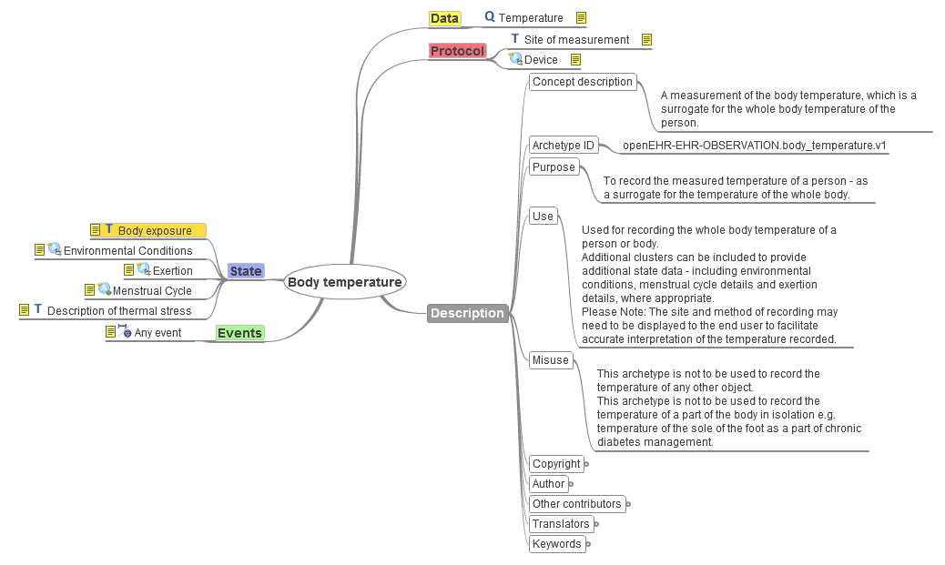

Figure 12 Sample CIC: Body Temperature Mind Map from openEHR CKM (Clinical Knowledge Manager)

* **BA (Business Architecture)** A blueprint of the enterprise that provides a common understanding of the organization and is used to align strategic objectives and tactical demands. A Business Architecture articulates the functional structure of an [enterprise](http://en.wikipedia.org/wiki/Business) in terms of its business services and [business information](http://en.wikipedia.org/wiki/Business_information) (shown in a BIM).
* **BIM (Business Information Model)** is a collection of information concepts and their relationships representing the business information needs for an iEHR Capability.
* **CDA (Clinical Document Architecture)** is an [XML](http://en.wikipedia.org/wiki/XML)-based markup standard intended to specify the encoding, structure and semantics of clinical documents for exchange. CDA is part of the HL7 version 3 standard based on the HL7 Reference Information Model (RIM) and the HL7 Version 3 Data Types. CDA documents are persistent in nature. The CDA specifies that the content of the document consists of a mandatory textual part (which ensures human interpretation of the document contents) and optional structured parts (for software processing). The structured part relies on coding systems (such as from [SNOMED](http://en.wikipedia.org/wiki/Systematized_Nomenclature_of_Medicine) and [LOINC](http://en.wikipedia.org/wiki/LOINC)) to represent concepts.
* **CDL (Constraint Description Language)** is used by Intermountain Health System.
* **CIC (Core Information Component)** Figure 12 shows a CIC mind map used to gather clinical input. The Core Information Components are defined as the minimum set of data items that are considered necessary to support the delivery of quality collaborative care. The inclusion of data in this minimal set is determined by two criteria:

1. The clinical relevancy of the data

2. The need for the data to ensure clinical safety in a collaborative care environment.

As these specifications define the Core Information Components for exchange, it is anticipated that some referral templates will contain additional types of data to satisfy specific local or specialty healthcare requirements. It is expected that national extensions to the Core Information Components will be defined to support particular specialty areas. [Core Information Components, Electronic Referrals Release 1.0, Version 0.26 — 15 February 2010

* + **openEHR [Thomas Beale, 20120923]:** Core Information Component (CIC) - I am not that sure I understand what this is, concretely. I assume it is thought to be a kind of model of low level content elements derived from terminology?
* **CIIF** (Common Information Interoperability Framework) CIIF defines information models and a data-concept dictionary of detailed description of all of the types of data elements used plus the context-sensitive attributes and relationships of those elements.  CIIF defines the use of controlled clinical terminologies as part of these models and CIIF includes additional services useful for translation and transformation of legacy information. CIIF can assure syntactic and semantic information interoperability, while supporting privacy (e.g., right to not disclose), confidentiality (e.g., promise to maintain control of information) and security (e.g., a mechanism that assures safety from unauthorized information disclosure) constraints. “*iEHR Common Data*” implies native use of a single logical database, specified by the CIIF.
  + CIIF design-time tools manage information-and-terminology models, a concept-dictionary and translation-models, information-exchange payload-models, XML schemas and Schematron. These design-time components provide **MDR** (Meta Data Repository) services to the run-time CIIF.
  + Based on the output of the CIIF design-time environment, the CIIF run-time services include **RLUS** (Retrieve, Locate, and Update Services) data translation services, information-exchange mediation-services, **CTS** (Common Terminology Services) and **BITE** (Built In Test Environment) services. CIIF services rely on Identification, Authentication, Authorization, Access and Secure Data Transport services to support Capabilities/Applications, **VPRs** (Virtual Patient Records) and the UX framework shown in Figure 14.
* **CIMI RM (Reference Model)** is the underlying Reference Model on which CIMI’s clinical models (i.e. archetypes) are defined. This reference model defines a rigorous and stable set of modeling patterns, including a set of structural patterns, complex data types and demographic classes. All CIMI clinical models (i.e. archetypes) will be defined by constraining the CIMI reference model. Each example instance of a CIMI Clinical Model will be an instance of the CIMI reference model, which conforms to the constraints defined by the associated clinical model.
* **CIMI (Clinical Information Model Initiative,** [**www.CIMIwiki.org**](http://www.CIMIwiki.org)**)** has the goal to share applications, business rules, services, reports, alerts, protocols, and decision support with anyone in the WORLD, including sharing a standard set of detailed clinical data models coupled with, standard coded terminology, standard API’s (Application Programmer Interfaces). CIMI is developing a reference model with data type specifications, modeling patterns and style guides for sharing models.
* **CLIM / SCS / CSP** have been categorized together; in reality, HL7 Clinical Statement Pattern (CSP), US iEHR CLIM (Common Logical Information Model) and NEHTA SCS (Structured Content Specification) differences may be subtle.  They may exist at different levels, have different approval processes, etc. Many logical models may be platform specific (e.g. XSD is very specific to XML, Java source code is specific to Java compilers, DDL to RDBMS.)
* **Clinical Templates** are flattened **PSMs** (Platform Specific Models, such as NIEM, CDA) “models-of-use”, with all necessary terminology and value set bindings. A CLIM anticipates implementation on a specific computing environment (e.g., JAVA, .NET, etc.) and are adjusted to achieve implementation efficiencies. Once validated and approved, the CLIM become the basis of a [physical data model](http://en.wikipedia.org/wiki/Physical_data_model) and can inform the design of an implementation paradigm, such as a message, document, service, component, database, etc. CLIMS are based on the structures identified in the DCMS, templates, archetype or FHIM [model](http://en.wikipedia.org/wiki/Conceptual_data_model)s. These models describe the semantics of the information context, which the CLIM must also reflect.
* **openEHR CONCEPT 1 [Thomas Beale, 20120923]: “**Logical Information Model (Clinical Template) - EpenEHR would call an operational template (**OPT**), and Intermountain a CE Type; this is a *fully flattened* 'source template', combining requisite pieces of various archetypes, designed for a purpose. The OPT form is its deployable form, a self-standing specification from which many other things can be generated, and which can also be used on its own. It defines the *legal configurations* of underlying reference information model instances that conform to the specific data set required, e.g. a specific kind of discharge summary, referral, lab report or whatever.
  + Our term 'operational template' is probably not the ideal term; I would suggest a term like **operational content model**. I think the term 'Logical Information Model' is too general and likely to be misconstrued as designating something more like a health data model, i.e. things like the base CDA, 13606 reference model, openEHR reference model and so on.
  + I suggest that this (if my understanding is correct) be shown as the output of a transform on an SCS (possibly with further rules, settings injected)”
* **openEHR CONCEPT 2 [Thomas Beale, 20120923 12:21]:** “Archetypes - as it happens, (openEHR) templates are related to (openEHR) archetypes by specialization rather than aggregation as shown, but the effect does include further constraining.. I think 'archetype' remains an acceptable term, since it is not otherwise overloaded. It is shown as 'constraining' an 'RM', which is correct, depending on what you mean by 'constrain' and 'RM' ;-)
  + the key thing to understand about archetypes in this modeling picture is that they don't define content in the sense of sets of data points / groups to be captured, stored, processed together. Instead, they should be understood as governance units, whose elements are grouped on the basis of natural affinity. In general, those elements will be chosen from multiple archetypes, by templates whose job it is to assemble an actual content definition.
* **CPOE** is Computerized Physician Order Entry.
* **DAM (Domain Analysis Model)** is an abstract representation of a subject area of interest, complete enough to allow instantiation of all necessary concrete classes needed to develop child design artifacts."
  + First, a DAM should represent the semantics-of-interest in terms that are understandable to domain experts, even though this may mean that 'not everyone gets to see their particular words represented,' i.e. they should, however, see the common concepts and relationships that describe the domain-of-interest in terms that are easily translatable to their favorite medical-domain-specific terms.
  + Second, a DAM must be semantically robust enough to support the development of down-stream design artifacts. Note that, depending on the degree of rigor applied to the term 'analysis,' a DAM may or may not be bound to formal data types and may or may not be formally/computationally traceable to one or more design artifacts.
  + Candidate “analysis DCMs” can be organized into a DAM. The DAM functions as a composition of DCMs, if needed. [William Goosen, 1-Oct-12]
  + *“How do you imagine this? A Domain Analysis Model is something like a model-of-information-characteristics specific to the domain in question; but, a DAM is abstracted sufficiently that they are supposed to be ~constant for all uses in that domain. [****Thomas Beale, 3-Oct-12****]*
    - *DCMs are guaranteed to be a monotonically increasing set of models of possible information content, modeled at the most specific level (certainly more specific granularity than a DAM).*
    - *As more content is described with these models, more models are created, each with its own data points/groups; and, existing DCMs can be augmented later on, when more details are deemed worthy of modeling. It's a fractal model space.*
    - *I can't imagine how a superposition of formally modeled DCMs could equal a DAM. At a stretch, a DAM might act as a reference model for archetypes, but it's not going to be a sum of them - if it were, it would be a giant, expanding profusion of data points, and not useful or usable in the aggregate form.*
    - *Personally, I have long since given up on DAMs as a useful tool - and I used to use them a lot. The reason is that because they try to cover he whole domain in a single model, they necessarily conflate multiple points of view - of the different kinds of domain participants, solutions etc - and they end up representing no point of view. But a model with no point-of-view or confused points-of-view doesn't work. It's a well-known problem in software engineering.*
    - *This is one of the advantages of discrete models like DCMs / archetypes / CEMs etc - each one says what is needed for the user type that uses it. I realize some of you think I am being pedantic, but we need to* ***a)*** *be on the same page with terminology and* ***b)*** *be able to draw diagrams, write documents etc. that have indisputable meaning - meaning that can be used to make decisions (such as define projects, tasks etc.). We can't do this if we don't know what we are saying with these terms, diagrams or documents.”*
  + *“If the aggregation relationship implies that the containing object is composed exclusively of the contained objects, then the diagram is incorrect, but that's not my understanding. During the development of the pressure ulcer prevention* [*DAM*](http://pressureulcerpreventionmodel.com/Reconciled/)*, we identified many small packages for which we provided clinical detail in hopes they might be used to develop reusable DCMs: these we called candidate DCMs. Rather than the DAM being "just a bag of models," we saw the candidate DCM as a product of the analysis process.” VA/DoD is in the process of defining a modeling methodology, which does not stipulate artifacts called DAMs. But it does call for business models, which I would classify with DAMs and other CIMs as models designed to capture requirements without constraint to design patterns. [Jay Lyle, 3-Oct-12]*
* **DCM** **or** **Archetype** is a universally understood symbol, term or pattern of behavior, a prototype upon which others are copied, patterned, or emulated. They are PIMs (Platform Independent Models aka “model-of-use”); for simplicity, they may initially be represented as an “Analysis DCM” or **Core Information Component (CIC)** Mind map, as shown in Figure 12 Sample CIC: Body Temperature Mind Map from openEHR CKM (Clinical Knowledge Manager). Archetypes and DCMs have associated data element definitions, vocabulary bindings, and related information. The CIC, archetype and DCM models are derived from requirements analysis for a discrete set of precise clinical knowledge, such as medication use or adverse reactions, which can be used in a variety of contexts. Unique clinical concepts can range from the simple, such as blood pressure, temperature or pulse, through to the complex, such as recording the risk of a condition from a positive family history. Archetypes and DCM examples might include “medication use”, "adverse reaction to drug or biological material", "acute dyspnea" or "abdominal exam", diagnosis, symptom, procedure. Note that things like medication list, problem list, allergy list, PMH (past medical history), etc. are views--filtered dynamic queries specific to an end user and are not archetypes or DCMs. Also, the domain of DCMs is typically areas, such as, clinical medicine, nursing, public health, and biomedical research; as a result, a DAM may not be helpful with these types of DCMs.  Initial terminology binding to SNOMED-CT, LOINC, RxNorm, NDF-RT, UNII, etc., generally occurs at the archetype or DCM level; but not for CICs.
  + *“Archetype can be considered partially conceptual, logical to the ADL specification, which also has implementation specifics.  Hence DCM and Archetype do have a similar role on the conceptual and the logical modeling stack level; however, there is an important difference, archetypes are ADL specific and ADL is implementation specific. That implies broader use of DCMs in favor of archetypes, and simultaneously DCMs always need more work at the logical implementation level, e.g. transformation into an archetype, but also transformation into HL7 clinical statements.  Basically some pros and some cons at the logical level. In an ontology of health / health systems, it is fine to include every specific, that is the order for. In the world of information models, I do like the categorization, it helps implementing the stuff.” [William Goosen, 1-Oct-12]*
  + **Archetype** is a computable expression of a domain content model in the form of structured constraint statements, based on an ISO 13606 reference model. Archetypes are expressed in ADL (Architecture Description Language). In general, they are defined for wide re-use, however, they can be specialized to include local particularities. Archetypes are logical information “models-of-use” and MAY have an associated CIC. ADL requires a reference model and can work with the HL7 RIM or ISO13606 Reference Model (RM). The RM defines the concrete form of the data (like Quantity, CodedText, Observation, etc). The archetypes define a library of clinical content elements like ‘blood pressure – systolic’ and groups like ‘diagnosis – occurrences’ once, and templates put the archetype together to make real-world data sets, define messages, forms etc. Archetype-based querying includes binding to terminology, where you state the relationship of terms and reference sets to information structures. openEHR Archetypes are platform specific, or at least spend a lot of their bulk devoted to a specific platform (i.e. the particular RM).  ADL workbench manages archetypes. There is an openEHR and a CIMI BMM (basic meta-model aka reference model) used to correctly express the semantics needed to perform archetype validation.
  + **Analysis DCMs (aka candidate DCMs)**, used by R4C, are conceptual-analysis models-of-meaning used to document requirements and to scope candidate DCMs; where, the "Candidate DCM's" may be plain UML, Mind Maps, or just text. Ultimately, the DCMs follow the R4C UML Style Guide, which implements (currently draft) ISO13972 <[http://results4care.wikispaces.com/1.1.+DCM\_UML\_StyleGuide](http://results4care.wikispaces.com/1.1.+DCM_UML_StyleGuide" \t "_blank)>. You might also call the analysis DCMs "Conceptual Information Models" with associated requirements. These candidate DCMs are to scope the analysis "work packages” to an applicable set of classes; where these Analysis DCMs and their associated requirements can be composed into a DAM (e.g., Immunization Management DAM includes Adverse Reaction, Medication, Allergy candidate DCMs). Conceptual-analysis DCMs serve the same purpose as NEHTA CICs and openEHR Mind Maps and are NOT considered reusable artifacts till they are DCMs, which are not considered interoperable till they are refined into run-time clinical templates, as shown above in Figure 2.
    - “*R4C DCMs are informed by implementation specific requirements as they are informed by clinical needs (e.g, the SHALL requirement to create one class per data element is based on the transformation to a clinical statement per data element or an archetype node for a data element.) We NEVER use the attribute specification option in UML to define a single data element. Another simple reason for doing so is what Peter Handler, KP said would be important:  make everything extensional; so that for each data element, the proper SNOMED CT code can be determined and that value sets can be expressed, if applicable. At the individual data element, where the rubber of the information model hits the road of the terminology model*.” [William Goosen 1-Oct-12]
  + **DCM (Detailed Clinical Model)** is a (currently draft) ISO 13972 logical-information “model-of-use” represented in OMG UML (Unified Modeling Language). DCMs do not have Reference Models; but, OMG is developing a “CIMI” profile specification, called AML, which will add a CIMI RM and constraint specifications. One-or-more DCMs and related requirements specification models may be composed into a DAM (e.g., immunization management).
    - [CIMI <http://informatics.mayo.edu/CIMI/index.php/Category:Detailed_Clinical_Model> ]
    - Most recent 100-or-so DCMs, are using the (currently draft) ISO 13972 specification and methodology. This again is a joint initiative council project with input from HL7, although it has not yet been balloted in HL7.
    - **[Thomas Beale, 20120923]:** as far as I understand, a 'DCM' is an informal/semi-formal documentary specification of a template, i.e. use-case specific data set. So I would diagram it as some kind of informal/documentary precursor to templates (i.e. your SCSs)
    - **[Stephen Chu, 20120923]:** The answer to the question, Is an NEHTA DCM = HL7 DCM? The simple answer to your question is: NO, they are different. NEHTA DCM are logical models derived from our openEHR archetypes that we developed. After the archetypes are “signed off” by the reviewing clinicians and the editorial panel, they undergo transformation processes which include removing some openEHR reference model constructs (e.g. those required for EHR record keeping and tracking) that are not relevant to our requirements, and make explicit some openEHR reference model constructs that are implicit, e.g. participants and participations. The logical models are then transformed into platform specific isosemantic models, e.g. the HL7 v2 segments and HL7 v3 classes. After the transform, we call them EDCM (exchangeable DCMs).
    - **[William Goosen, 20120923]:** “The answer to the question, “do R4C DCMs equal HL7 DCMs”, is definitely yes, but incompletely.
      * In HL7 the DCM need to be transformed into a Clinical Statement series (1-n) to fit in the messages or CDA. That is similar to the step from a DAM to a DMIM, but small scale. Michaels EA tool does this automatically which delivers valid hl7 v3 Xml against CSP and CARE Record.
      * The R4c DCM are not R4C. They are owned by Nictiz for the 23 for diabetes, the Parelsnoer project of the 8 Dutch university hospitals biomedical research, this are about 40. Then the OLVG hospital owned about 20. the 19 users of KD+ software for child health records own 5, SRE ones 25, Actiz 6, Nictiz about 75 for stroke care and Health Base about 8. Some additional ones ate jointly owned.
        + The older ones are specified in spreadsheets and HL7 v3 RMIMs ready to be templates.
    - **Michael van der Zel 20120924]:** The way I use the DCM's are as instructions for platform specific artifacts. So they are pim's.
* If your psm is HL7v3 templates then I will generate HL7v3 templates.
* If your psm is A\_SupportingClinicalStatement then I will generate example instances (no values) for that.
* If your psm is an openEHR system I will generate openEHR ADL's.
* If your psm is CDA R2 then I will generate an example instance for that..

All from the same DCM + a transformation to include the specifics (boilerplate) of the choosen psm. The extra's are the who/when/where stuff that is different in each psm. E.g. HL7 v3 we talk about R\_Patient, in openEHR it is called something else. Same is for the when part, in HL7 v3 this is the effectiveTime, for openEHR this is different, etc. etc.

* And then we have the HL7 DCM's. For me they are actually psm's were you already picked the HL7 v3 CSP as your platform. I scanned Kevin's "HL7 DCM" document, and this underwrites this.
* It get's somewhat harder when we talk about CIMI. The CIMI models are somewhere between the DCM's and the PSM models. The CRM (CIMI Reference Model) contains more "stuff" and the more "stuff" that get's in there the harder it is to transform it to different PSM's. With stuff I mean the who/when/where and some patterns. So far I managed to generate CIMI ADL's from the DCM's (see the openEHR subversion for examples).
* I am now thinking about plotting all the artifacts in the SAIF MATRIX. I really like that ordering. Most of the times I place DCM's at the Conceptual level together with the DAM. For me the DCM's are a more formal way to write information requirements without binding it to a certain platform (like HL7 v3, v2, openEHR, ...).
* **[William Goosen, 20120925]:** The 13972 DCMs would need to sit in the logical space in the SAIF Matrix as well.  
  Based on in particular comments from Stephen C to ISO. the definition has been changed from conceptual and some logic applied to conceptual and logical. More nuance in the DTS 13972.
  + - **[Kevin Coonan, 20120924]** First, DCMs**\*** are wickedly concrete and quite specific.  They define what is, and what is not sensible to say about a particular piece of clinical content.  They reflect, but do not express, clinical knowledge.  Clinical data, in the minds, and artifacts, of clinicians, is highly structured.  DCMs reflect this structure in their design.
* They may not be expressed always in a formal grammar, which is where informaticists and tools are needed.
* Trust me when I tell you there is a rigid formalism, with mandatory and optional typed data, when you call an obstetrician or orthopedist on the phone in the middle of the night about a consult in the ED/A&E.  Whether you call this conceptual or something else does not matter.  That is what we need CIMI to be able to represent.
* These real world things, when fully defined and expressed explicitly, are the stuff of DCMs.
* CIMI models, whether you call them conceptual or not, need to be able to represent DCMs very logically and formally.  They need to be technology artifacts representing real world things.
* There are emerging standards for what needs to be included as metadata and background information.  William has been working this out in ISO and it should come to JIC for review soon.
* If the CIMI UML2 language does this, without being encumbered by the implementation crust we deal with in implementable standards, it will succeed.  The reference model for these needs to be, or at least act like, an upper level ontology.  It doesn't need to be perfect, just suited to task.  The Buffalo crowd doesn't get this.  We are not going to build an ontology of everything when our domain of discourse is clinical data!
* For us, then, the information model is not the vocabulary ontology, and not the reference model ontology, nor is it the constraints on the RM which restrict it to say things with meaning.  It is the totality of these.  This is what the CIMI models need to convey.  Whether done in one, two, three, four, or twelve layers is a matter of cost, benefit, risk, and alternatives.
* The test of whether a modeling language works (UML2 w/ OCL, ADL with multilayer stack, ASN.1\*\*, RDF-S, HL7 v3 multilayer stack, CEM) is whether or not is can represent this reality with fidelity AND it can be used to generate the other artifacts (HL7 templates in my neighborhood, 13606 Archetypes, IHC CEMs, openEHR archetypes/templates) we need to run production systems.
* The whole CIM/CLIM/PSM cramps our thinking, esp. when you mix in platform (in)dependency,  we can push a button and convert some CLIMs into other CLIMs, which can be converted into other CLIMs, PSMs, and even pretty pictures (conceptual?).   I don't think these terms help us as much as we would like them to.
* We have design patterns at different levels of granularity.  At the final, leaf, end of detail, we no longer have reusable design patterns but rather the model of reality.  If we need a vocabulary for levels of abstraction how is this:  design pattern (reuse and consistency are major objectives, e.g. an "observation", "temporal series"), abstract models (represent abstractions of real world things, perhaps at the ontological class level, eg "clinical finding", "exam finding", "extremity finding" are at this level) and DCMs (say goodbye to the model optionality, the "one true way").
* You can lump in, or split out as a another layer, if you want to call a special set of design patterns a RM.  Or even two, if you want to call complex reusable classes 'data types' rather than accepting the standard definition as something which holds a single value.  :)

**\*** not to be confused with the HL7 DCM standard we are working on which detail how, in HL7 standards, something like a CIMI model is represented so it can be implemented in HL7 v3 CDA (r3), messages, web services, decision support APIs etc.

**\*\*** or cuneiform, or hieroglyphics, or linear B, which I believe is the direct ancestor of ASN.1.  :)

* + ADL Archetypes can be transformed to UML DCMs and vise-a-versa. Theoretically, ADL is more expressive (better able to represent constraints) than UML; potentially, ADL to UML transformation might lose some ADL constraint information. Currently, round trip transformations are helpful to verify isomorphism; however, the OMG is developing a CIMI UML profile to make UML equivalent to ADL in representation capability. NEHTA and Connect4Health have developed ADL-UML translators.
    - **[Thomas Beale, 20120920]:** Note that, UML class inheritance is additive; while, ADL archetype “inheritance” is subtractive; because ADL is a constraint language. This implies that, the openEHR and CIMI Reference Models must specify the universe of possible data elements.

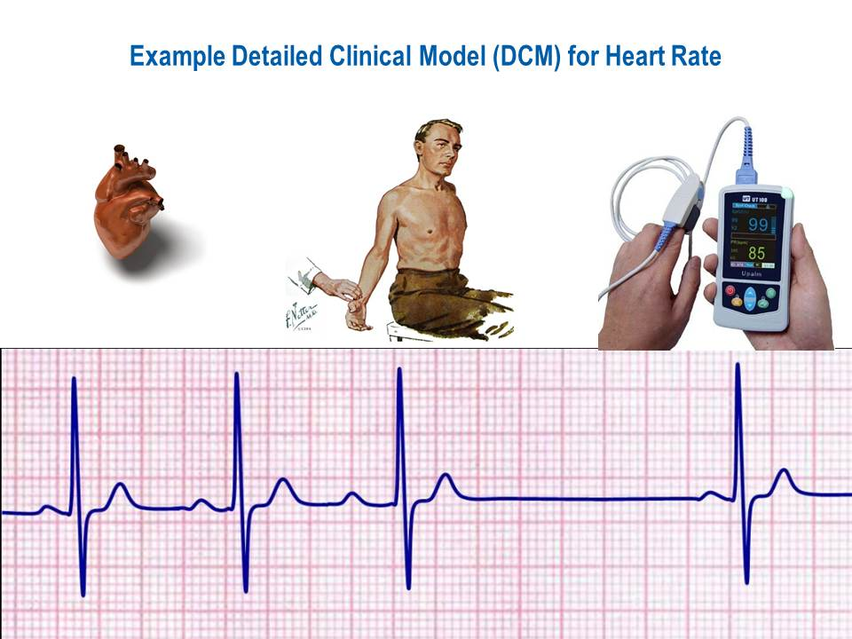

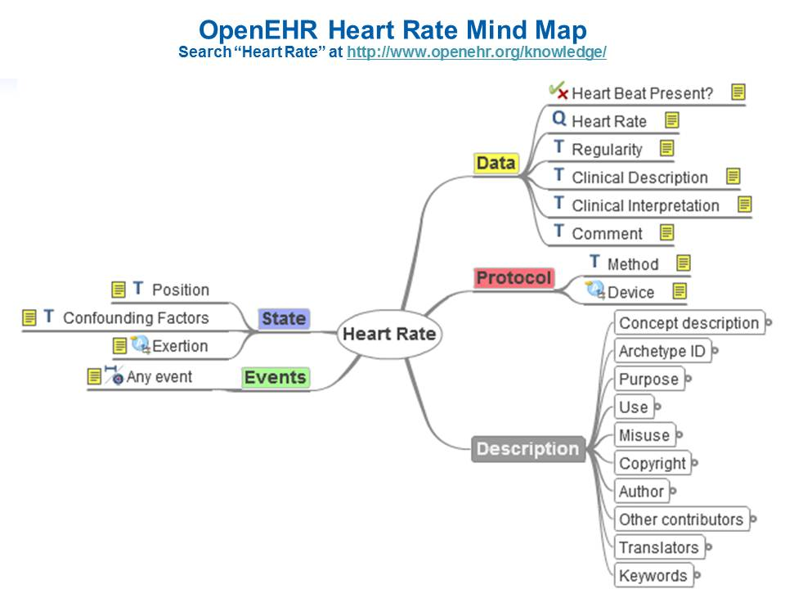

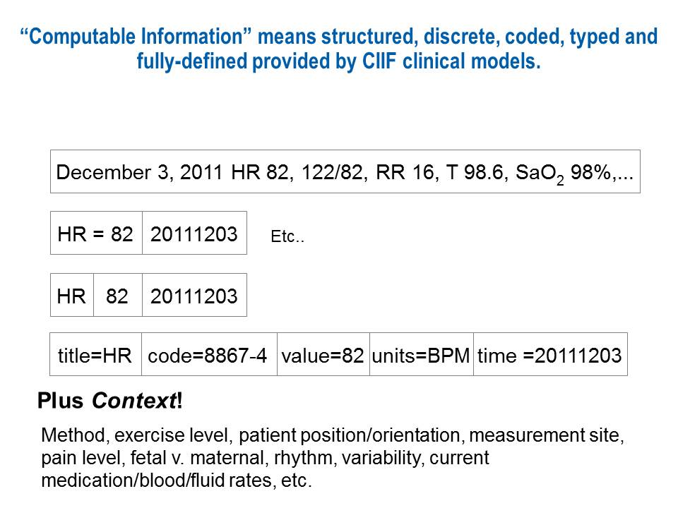

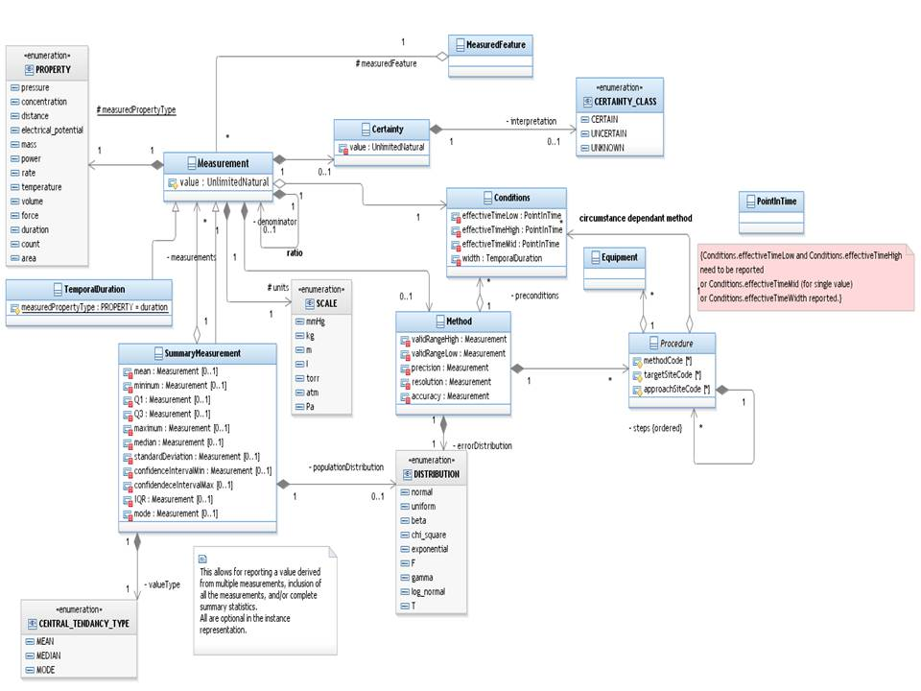

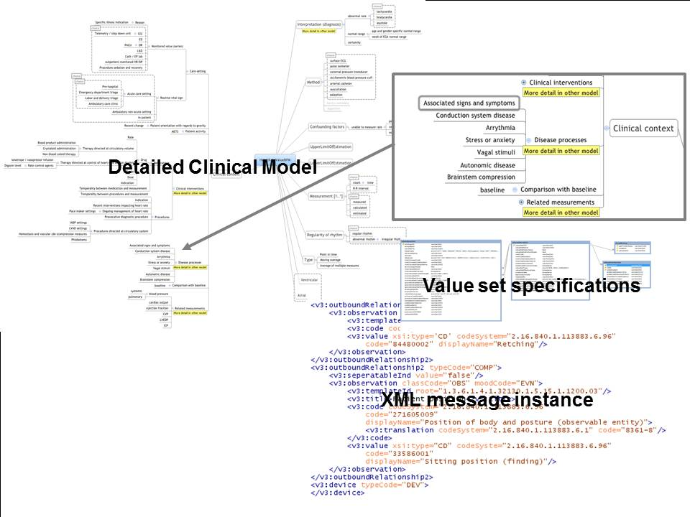

openEHR Heart Rate Archetype

Search Heart Rate at <http://www.openehr.org/knowledge/>

archetype (adl\_version=1.4)

openEHR-EHR-OBSERVATION.heart\_rate.v1

concept

[at0000] -- Heart Rate

language

original\_language = <[ISO\_639-1::en]>

description

original\_author = <

["name"] = <"Sam Heard">

["organisation"] = <"Ocean Informatics">

["email"] = <"sam.heard@oceaninformatics.com">

["date"] = <"2006-03-26">

>

details = <

["en"] = <

language = <[ISO\_639-1::en]>

purpose = <"To record the the measurement of the heart rate and characteristics related to the rhythm of the heart.">

use = <"Use to record the measurement of heart rate and characteristics related to the rhythm of the heart, including a simple statement of presence of a heart beat. These are not recorded by direct observation of the heart itself but inferenced from alternative sources including the direct auscultation of the heart or electronic monitoring of the electrical activity of the heart.

Heart rate and rhythm (or its specialisation, Pulse) are commonly recorded as one component of Vital signs - typically comprising Blood Pressure, Respirations, Temperature, and Oximetry. There are additional specific archetypes for each of these concepts.

Measurements such as average or maximum heart rate over a period of time can be recorded using this archetype's interval event model within a template or at run-time.">

keywords = <"rate", "heart rate", "rhythm", "beat">

misuse = <"Not to be used to record the rate, rhythm and related characteristics about peripheral pulses - this is recorded using the specialisation of this archetype OBSERVATION.heart\_rate-pulse.

Not to be used to record the heart rate in the context of an Electrocardiograph interpretation or report - this will be recorded using the OBSERVATION.ecg archetype.

Not to be used to record other details of the broader cardiovascular examination or assessment. Other specific archetypes will be used to record characteristics such as apex beat, murmurs, auscultatory findings etc.

Not to be used to record fetal heart rate - this is recorded using the OBSERVATION.fetal\_heart archetype.

Concepts such as Target Heart Rate should be recorded in separate archetypes specifically related to goals and exercise assessment.">

copyright = <"© openEHR Foundation">

>

>

lifecycle\_state = <"CommitteeDraft">

other\_contributors = <"Koray Atalag, University of Auckland, New Zealand", "Rong Chen, Cambio Healthcare Systems, Sweden", "Stephen Chu, NeHTA, Australia", "Angela de Zwart, Orion Health, New Zealand", "Graham Denyer, Australian Antarctic Division, Australia", "Paul Donaldson, Nursing Informatics Australia, Australia", "Sebastian Garde, Ocean Informatics, Germany", "Sam Heard, Ocean Informatics, Australia", "Evelyn Hovenga, EJSH Consulting, Australia", "Eugene Igras, IRIS Systems, Inc., Canada", "Athanasios Kleontas, Ergobyte Informatics, Greece", "Shinji Kobayashi, Ehime University, Japan", "Robert Legan, NEHTA, Australia", "Heather Leslie, Ocean Informatics, Australia (Editor)", "Rohan Martin, Ambulance Victoria, Australia", "Ian McNicoll, Ocean Informatics, United Kingdom (Editor)", "Jeroen Meintjens, Medisch Centrum Alkmaar, Netherlands", "Monica Merchat, Hospital Cardiac Electrophysiology, MS Health Informatics Student, former ICU nurse, former Anesthesia Technician, United States", "Arturo Romero, SESCAM, Spain">

other\_details = <

["MD5-CAM-1.0.1"] = <"D26994E69C2C259EFE8E4E22E63CE857">

>

definition

OBSERVATION[at0000] matches { -- Heart Rate

data matches {

HISTORY[at0002] matches { -- history

events cardinality matches {1..\*; unordered} matches {

EVENT[at0003] occurrences matches {0..\*} matches { -- Any event

data matches {

ITEM\_TREE[at0001] matches { -- structure

items cardinality matches {0..\*; unordered} matches {

ELEMENT[at1005] occurrences matches {0..1} matches { -- Heart Beat Present?

value matches {

DV\_BOOLEAN matches {

value matches {True, False}

}

}

}

ELEMENT[at0004] occurrences matches {0..1} matches { -- Heart Rate

value matches {

C\_DV\_QUANTITY <

property = <[openehr::382]>

list = <

["1"] = <

units = <"/min">

magnitude = <|>=0.0|>

precision = <|0|>

>

>

>

}

}

ELEMENT[at0005] occurrences matches {0..1} matches { -- Regularity

value matches {

DV\_CODED\_TEXT matches {

defining\_code matches {

[local::

at0006, -- Regular

at0007, -- Regularly irregular

at0008] -- Irregularly irregular

}

}

}

}

ELEMENT[at1022] occurrences matches {0..1} matches { -- Clinical Description

value matches {

DV\_TEXT matches {\*}

}

}

ELEMENT[at1023] occurrences matches {0..\*} matches { -- Clinical Interpretation

value matches {

DV\_TEXT matches {\*}

}

}

ELEMENT[at0009] occurrences matches {0..1} matches { -- Comment

value matches {

DV\_TEXT matches {\*}

}

}

}

}

}

state matches {

ITEM\_TREE[at0012] matches { -- List

items cardinality matches {0..\*; unordered} matches {

ELEMENT[at0013] occurrences matches {0..1} matches { -- Position

value matches {

DV\_CODED\_TEXT matches {

defining\_code matches {

[local::

at1003, -- Standing

at1001, -- Sitting

at1002, -- Reclining

at1000; -- Lying

at1001] -- assumed value

}

}

}

}

ELEMENT[at1018] occurrences matches {0..1} matches { -- Confounding Factors

value matches {

DV\_TEXT matches {\*}

}

}

allow\_archetype CLUSTER[at1017] occurrences matches {0..\*} matches { -- Exertion

include

archetype\_id/value matches {/openEHR-EHR-CLUSTER\.level\_of\_exertion(-[a-zA-Z0-9\_]+)\*\.v1/}

}

}

}

}

}

}

}

}

protocol matches {

ITEM\_TREE[at0010] matches { -- List

items cardinality matches {0..\*; unordered} matches {

ELEMENT[at1019] occurrences matches {0..1} matches { -- Method

value matches {

DV\_TEXT matches {\*}

}

}

allow\_archetype CLUSTER[at1013] occurrences matches {0..1} matches { -- Device

include

archetype\_id/value matches {/openEHR-EHR-CLUSTER\.device(-[a-zA-Z0-9\_]+)\*\.v1/}

exclude

archetype\_id/value matches {/.\*/}

}

}

}

}

}

ontology

terminologies\_available = <"SNOMED-CT", "LOINC">

term\_definitions = <

["en"] = <

items = <

["at0000"] = <

text = <"Heart Rate">

description = <"Measurement of the heart rate and description of associated characteristics.">

>

["at0001"] = <

text = <"structure">

description = <"@ internal @">

>

["at0002"] = <

text = <"history">

description = <"@ internal @">

>

["at0003"] = <

text = <"Any event">

description = <"Default, unspecified point in time or interval event which may be explicitly defined in a template or at run-time.">

>

["at0004"] = <

text = <"Heart Rate">

description = <"The rate of the heart in beats per minute.">

>

["at0005"] = <

text = <"Regularity">

description = <"The observed regularity of the heart rate.">

>

["at0006"] = <

text = <"Regular">

description = <"Heart rhythm is regular.">

>

["at0007"] = <

text = <"Regularly irregular">

description = <"Heart rhythm is regularly irregular.">

>

["at0008"] = <

text = <"Irregularly irregular">

description = <"Heart rhythm is irregular in a chaotic manner.">

>

["at0009"] = <

text = <"Comment">

description = <"Comment about the heart rate.">

>

["at0010"] = <

text = <"List">

description = <"@ internal @">

>

["at0012"] = <

text = <"List">

description = <"@ internal @">

>

["at0013"] = <

text = <"Position">

description = <"The position of the patient when the heartbeat was recorded.">

>

["at1000"] = <

text = <"Lying">

description = <"Lying flat at the time of heart rate measurement.">

>

["at1001"] = <

text = <"Sitting">

description = <"Sitting (for example on bed or chair) at the time of heart rate measurement.">

>

["at1002"] = <

text = <"Reclining">

description = <"Reclining at the time of heart rate measurement.">

>

["at1003"] = <

text = <"Standing">

description = <"Standing at the time of heart rate measurement.">

>

["at1005"] = <

text = <"Heart Beat Present?">

description = <"Is a heart beat present?">

comment = <"The heart beat is present is implied as true if rate >0.">

>

["at1013"] = <

text = <"Device">

description = <"Details about the device used to observe the heart rate and rhythm.">

>

["at1017"] = <

text = <"Exertion">

description = <"Details about physical exertion being undertaken at the time of recording heart rate and/or rhythm.">

>

["at1018"] = <

text = <"Confounding Factors">

description = <"Narrative description about any incidental factors that may be contributing to the heart rate observations.">

comment = <"For example, presence of a pacemaker, level of anxiety; pain or fever etc.">

>

["at1019"] = <

text = <"Method">

description = <"Method used to measure the heart rate.">

comment = <"For example, auscultation or electronic monitoring. ">

>

["at1022"] = <

text = <"Clinical Description">

description = <"Narrative description of the heart rate.">

>

["at1023"] = <

text = <"Clinical Interpretation">

description = <"Single word, phrase or brief description representing the heart rate findings.">

comment = <"Coding with a terminology is preferred, where possible. Examples include: Bradycardia, Extrasystoles or Sinus rhythm. Multiple statements are allowed. ">

>

>

>

>

term\_bindings = <

["SNOMED-CT"] = <

items = <

["at0004"] = <[SNOMED-CT::364075005]>

["at0005"] = <[SNOMED-CT::364074009]>

["at0006"] = <[SNOMED-CT::248649006]>

["at0007"] = <[SNOMED-CT::248652003]>

["at0008"] = <[SNOMED-CT::248651005]>

["at0013"] = <[SNOMED-CT::422431001]>

["at1000"] = <[SNOMED-CT::40199007]>

["at1001"] = <[SNOMED-CT::33586001]>

["at1002"] = <[SNOMED-CT::272580008]>

["at1003"] = <[SNOMED-CT::10904000]>

["at1019"] = <[SNOMED-CT::386053000]>

>

>

["LOINC"] = <

items = <

["at0004"] = <[LOINC::8893-0]>

["at0013"] = <[LOINC::8361-8]>

>

>

>

* **FHIM (Federal Health Information Model)** is a US realm **PIM** (Platform Independent Model) composite logical model-of-meaning being developed by the Federal agencies under HHS FHA. FHIM is available on the OHT web site. FHIM acts as a model repository, harmonizing across DCMs and templates and can be a source for CLIMs.
* **IBRM (Integrated Business Reference Model)** is a joint activity model developed by the DOD and VA.
* **iEHR** (integrated EHR) is a shared US DoD-VA (Department of Defense and Veterans Administration) development to ensure that practitioners and patients will have access to 75 plus years of lifelong electronic medical record for benefits and healthcare with relevant and accurate information, including semantically standardized computable data elements for analytic and cognitive decision support systems, that are presented in meaningful ways to support clinical continuity-of-care management of patients and populations. This is essential to effective, efficient, and consistent patient care management in executing medical missions for beneficiaries from the time of accession or conferral of health benefits through marriage or birth until 75 years beyond the end-of benefit-and-care. iEHR is a Healthcare Services Platform (**HSP**) emphasizing the *reuse* of high quality clinical, business, and infrastructure services, a Common Information Interoperability Framework (**CIIF**), a User Experience (**UX**) standards-based portal-type presentation framework and a standards-based virtual data repository (**VDR**), as is shown in Figure 1. The HSP is intended to be an interoperability-framework for **COTS** (Commercial Off-The-Shelf), **GOTS** (Government Off-The-Shelf) and open-source applications or components, which use and publish HSP services. In accordance with scope-of-practice, organizational policy, and jurisdictional law. Each medical specialty-domain is an orchestration of HSP services; with centrally-managed and locally-customized data-and-terminology models, business rules, workflows, reports and displays.
* **iEHR Reusable Component** emphasizes the ability of capabilities being an orchestration of EHR clinical/business, SOA Suite/ESB, UX Framework and VDR component services; at IOC (Initial Operating Capability), the core EHR HSP clinical/business services should, ideally, be provided by legacy-systems’ service-façades; at FOC (Final Operating Capability), the same EHR services should be exclusively provided by iEHR HSP components. Most importantly, the key clinical/business services for medical-specialty domain (e.g., immunization, emergency, pediatrics, orthopedics, etc.) orchestration requiring customization of information and terminology models, business rules, workflows and UX presentation portals are:

1. **Virtual Patient Record (VPR) Service** to collate data from all legacy sources and use it as if it were coming from one source
   1. **RLUS (Retrieve, Locate Update Service)** fronted databases and COOP (continuity-of-operation) and performance caches
   2. **CIIF (Common Information Interoperability Framework)** information-and-terminology models and services supporting VPR
2. **Care Coordination Services**[[5]](#footnote-5)enabling “medical-home” type patient-care management
   1. Problems, including Diagnosis and Allergies
   2. Treatments, including Medication List and Procedures
   3. Diagnostic Test Results, including Radiology Reports, Radiology Images, Pulmonary Function Tests, Electrocardiograms, Laboratory Test Results, Microbiology Results, Pathology Reports, Synoptic Pathology Reports, Pathology Images
   4. Demographics, Advance Directives and Patient / Family Preferences
3. **Orders Management Service**, ideally, provided within the Care Coordination Service
4. **Note Writer Service**, ideally, provided within the Care Coordination Service
5. **Inventory and Funds-Control Management Services**
6. **CDS (Clinical Decision Support)**, possibly built from the Business Rules Service
7. **UX Portal Framework** enables SSO (single sign on), CM (context management), AM (access management), ID (identification), secure-mobile devices and medical-domain-specific portlets, which are pluggable user interface components

* **HL7 Clinical Statement** is an HL7 model designed to be used within multiple HL7 Version 3 domain models. A Clinical Statement is intended to facilitate the consistent design of communications that convey clinical information to meet specific use cases. In most cases Clinical Statement will be refined for use within a model, which is using the Clinical Statement that enables different workgroups to consistently incorporate clinical statement patterns in their domain as templates, CMETs, or other valid methods. Common Message Element Types (CMETs) are standardized model fragments intended to be building blocks that individual content domains can "include" in their designs. These blocks reduce the effort to produce a domain-specific design and assure that similar content across multiple domains is consistently represented.
* **HL7 Clinical Template** is a set of one or more observations, identified as by a single name and code number, and treated as a shorthand unit for ordering or retrieving results of the constituent observations. … Vital signs, electrolytes, routine admission tests, and obstetrical ultrasound are all examples.”
* **HL7 DCM (Detailed Clinical Model)** [ <http://wiki.hl7.org/index.php?title=Detailed_Clinical_Models> ] is an information model of a discrete set of precise clinical knowledge which can be used in a variety of contexts and are generally published as HL7 Templates. *“A DCM is intended to be agnostic or neutral with respect to reference model and platform. For a DCM to be used in applications, it needs to be transformed into platform specific artifacts, for example HL7 templates or ISO 13606 or openEHR archetypes (true?).”* “*The HL7 specific application of DCMs will be published as a Template which constrains the Clinical statement pattern following the TermInfo guidance on use of controlled terminologies. It is also likely that in addition to any template specification, it will include additional machine process-able definition and constraints needed for a computer program to 'understand' a given DCM, with the intent of providing a plug-in type mechanism where ERHs and other healthcare IT platforms can add new content directly without requiring separate implementation.*” Detailed Clinical Models (DCM) are descriptions of items of clinical information that include the clinical knowledge on the concept, the data specification, a model; and, where possible, technical implementation specifications. A DCM is a conceptual PIM (Platform Independent Model—of-meaning) specification of the semantics of discrete structured clinical information. It provides the data elements and attributes, including the possible values and types of the attributes, needed to convey the clinical reality in a fashion that is understandable to both clinical domain experts and modelers. This includes the potential for use in health care information and communication technology, for example in EHR, telehealth applications, messages, medical devices, computer algorithms, and deductive reasoning, decision support, among others. It provides unambiguous detail which is intended to be cross domain and cross discipline and standardized and reusable over domains, purposes, standards and implementations. DCM work currently includes clinical content analysis, quality assurance, information modeling, and repositories. DCM include the structural model. Dynamic models are handled DAMs, but some aspects of dynamics might be in the DCM. “*In HL7 the DCM needs to be transformed into a Clinical Statement series (1-n) to fit in the messages or CDA. That is similar to the step from a DAM to a DMIM, but on a smaller scale. Michael van der Zel’s EA tool does this automatically. The tool delivers valid hl7 v3 Xml against an CSP (clinical statement pattern) and CARE Record*.” [William Goossen, 2012-09-23]
* **HL7 EHR System Function and Information Model (EHR-S FIM)** contains functional profiles; this model provides a standard description and common understanding of functions and information conformance criteria for healthcare settings. Release 1.1 is published and Release 2.0 is under revision and is targeted for HL7 ballot in 2013 and the information models are targeted for inclusion in 2014.
* **HL7 FHIR (Fast Healthcare Interoperability Resources**, pronounced "Fire") defines a set of "[Resources](http://wiki.hl7.org/index.php?title=Resource)" that represent granular clinical concepts. [http://wiki.hl7.org/index.php?title=FHIR] The resources can be managed in isolation (e.g., CIMI archetypes or DCMs), or aggregated (e.g., CIMI SCS) into complex documents. This flexibility offers coherent solutions for a range of interoperability problems. The simple direct definitions of the resources are based on thorough requirements gathering, formal analysis (e.g., CIMI CIC) and extensive cross-mapping to other relevant standards (e.g., MDHT). A workflow management layer provides support for designing, procuring, and integrating solutions. Technically, FHIR is designed for the web; the resources are based on simple XML, with an http-based RESTful protocol where each resource has predictable URL. Where possible, open internet standards are used for data representation.
* **HL7 RIM (**Reference Information Model) expresses the data content needed in a specific clinical or administrative context and provides an explicit representation of the semantic and lexical connections that exist between the information carried in the fields of HL7 messages and documents. The RIM provides the useful abstraction/framework of “*Entities in Roles, Participating in Acts, and Acts related to Acts*”. But, the RIM has the difficulty of generating XML implementation artifacts and specifically the difficulty of dealing with RIM’s XML Model Interchange Format (MIF) files for which there are no standard tools. There is no clear path from the RIM Class models, which are easy to understand, to the actual XML serializations needed in implementations; simply stated, you cannot simply use XSDs.

RIM based models use a different graphic notation than standard UML2; and, they have a higher degree of specification than the off-the-shelf UML class diagrams.  The computable version of an HL7 v3 model is in MIF2 rather than XMI. The RIM graphic notation was adopted to do away with association classes and to make the models compact enough to deal with in Visio.  The RIM can be defined using an UML2 profile, which you can download and import into compliant tools; it is available in XMI and RSA 8 file formats.  The added properties are well documented in the current RIM specification.  UML2 HL7 RIM models require a meta-class reference model, profiles/extensions and OCL modeling-by-constraint paradigm to be implemented in MDHT; where, the modeling-by-constraint paradigm is widely used in Model Driven Architecture.

* **JSR 286 Portlet** Standard defines Portlets, which are web-based components that enable integration between applications and portals and thus enable delivery of applications on portals. The Java Portlet Specification achieves interoperability among portlets and portals by defining the APIs for portlets. In February 2006 the JSR 286 Expert Group was formed to start work on Java Portlet Specification 2.0, and the final version was approved in June 2008.
* **MDHT (Model-Driven Health Tools)** Open Health Tools (OHT) Project is a wide-ranging open source effort to promote interoperability in healthcare infrastructure. It promotes shared artifacts between related healthcare standards and standards development organizations, and works to develop localized specifications. It also delivers a common modeling framework and tools that support seamless integration of design, publication, and runtime artifact creation. MDHT allows the creation of computable models of CDA and NIEM templates in UML. These models may be used to produce:
* Template Specifications (DITA, XHTML, PDF, Other), Conformance/Validation Tools
* Model Driven Code Generation, Schematron (work in progress)

The project has already built models from the following specifications:

* HL7 Continuity of Care Document, HITSP C83 Sections and Entries
* IHE Patient Care Coordination Technical Framework
* HL7 Common Document Types, HL7 Consolidated CDA (DSTU Dec 2011)
* HL7 CDA IG : Public Health Case Reports (US Realm),
* HL7 CDA IG : Personal Healthcare Monitoring Report (PHMR)
* **Message Model** is a set of specifications for a message interface to exchange clinical data. The specifications will detail important information regarding the interface including the following:
* Communication protocol
* [HL7 standard](http://www.corepointhealth.com/resource-center/hl7-resources) version
* [HL7 message](http://www.corepointhealth.com/resource-center/hl7-resources/hl7-messages" \t "_blank" \o "HL7 Message Definition)(s) to be sent or received
* Message format or segment layout for each message
* Field list for all segments including [Z segments](http://hl7standards.com/blog/2006/10/05/what-are-z-segments/)
* Other details (e.g., use requirements, field content, optionality, etc.)
* **Model-of-Meaning**, according to Alan Rector, represents “What is sensible to say about…” The basic unit is the thing being described; **Models-of-meaning** are ontologies, which are about the things being represented – patients, their diseases. They are about what is always true, whether or not it is known to the clinician. For example, all patients have a body temperature (possibly ambient if they are dead); however, the body temperature may not be known or recorded. It makes no sense to talk about a patient with a "missing" body temperature.
* **Model-of-Use**, according to Alan Rector, represents What is relevant and useful to say about “when” (workflow) it is needed – “what” should be “handy” (context) to use …” and the priorities and work flows of the use of …; where, the basic unit is the “task” being performed. In Figure 1 and in Figure 2 a DCM supports specific use cases and Business Process Model (BPM). As an example, a DCM’s model-of-use would state that MDHT transforms a DCM into one-or-more clinical templates. **Models-of-use** are data structures, such as DCMs or clinical templates, which are about the artifacts in which information is recorded. Not every data structure about a patient need include a field for body temperature, and even if it does, that field may be missing for any given patient. It makes perfect sense to speak about a patient record with missing data for body temperature.
* **Model-of-Implementation**, according to Alan Rector, represents “How a model is to be used”. In Figure 1 and in Figure 2 a clinical template is used to specify information-exchange content and Built-In-Test-Environment (BITE) schematron supporting various information-exchange paradigms, such as services, messages, documents.
* **NIEM (National Information Exchange Model)** is an [XML](http://en.wikipedia.org/wiki/XML)-based information exchange framework from the [United States](http://en.wikipedia.org/wiki/United_States). NIEM represents a collaborative partnership of agencies and organizations across all levels of government (federal, state, tribal, and local) and with private industry. The purpose of this partnership is to effectively and efficiently share critical information at key decision points throughout the whole of the [justice](http://en.wikipedia.org/wiki/United_States_Department_of_Justice), [public safety](http://en.wikipedia.org/wiki/Department_of_Public_Safety), [emergency and disaster management](http://en.wikipedia.org/wiki/Emergency_management), [intelligence](http://en.wikipedia.org/wiki/Director_of_national_intelligence), and [homeland security](http://en.wikipedia.org/wiki/United_States_Department_of_Homeland_Security) enterprise. NIEM is designed to develop, disseminate, and support enterprise-wide information exchange standards and processes that will enable [jurisdictions](http://en.wikipedia.org/wiki/Jurisdictions) to automate information sharing.
* openEHR [Clinical Knowledge Manager (CKM)](http://www.openehr.org/knowledge) is at <http://www.openehr.org/knowledge/>
* **RDF (Resource Description Framework)** [ <http://www.w3.org/RDF/> ] is a W3C standard model for data interchange on the Web. RDF has features that facilitate data merging even if the underlying schemas differ, and it specifically supports the evolution of schemas over time without requiring all the data consumers to be changed. RDF extends the linking structure of the Web to use URIs to name the relationship between things as well as the two ends of the link (this is usually referred to as a “triple”). Using this simple model, it allows structured and semi-structured data to be mixed, exposed, and shared across different applications. Figure 13 shows how this linking structure forms a directed, labeled graph, where the edges represent the named link between two resources, represented by the graph nodes. This *graph view* is the easiest possible mental model for RDF and is often used in easy-to-understand visual explanations. SPARQL the syntax and semantics of the RDF query language. SPARQL can be used to express queries across diverse data sources, whether the data is stored natively as RDF or viewed as RDF via middleware. SPARQL contains capabilities for querying required and optional graph patterns along with their conjunctions and disjunctions. SPARQL also supports extensible value testing and constraining queries by source RDF graph. The results of SPARQL queries can be results sets or RDF graphs. NIST recommends and DOD has mandated the use of RDF, its SPARQL query language. Semantic Web technologies including RDF and Web Ontology Language (OWL) for defining ontologies and describing meta-data using these ontologies as well as tools for reasoning over these descriptions. NIST recommends using these technologies to provide common semantics of Service information and policies enabling all agents who understand basic Semantic Web technologies to communicate and use each other’s data and Services effectively. The Ontology Web Language for Services (OWL-S) was developed to provide a vocabulary for describing the properties and capabilities of Web Services in unambiguous, computer-interpretable form. OWL-S allows Service providers or brokers to define their Services based on agreed upon ontologies that describe the functions they provide.

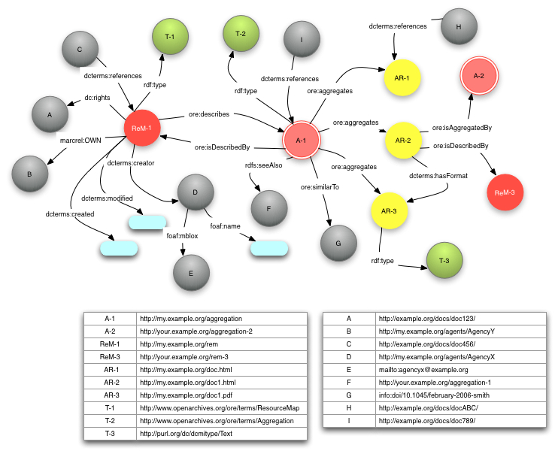

Figure 13 Example RDF Graph

* **RLUS (Retrieve, Locate and Update Service) [** [**http://www.omg.org/spec/RLUS/**](http://www.omg.org/spec/RLUS/) **] Service Functional Model (RLUS SFM)** is a HL7 and OMG functional standard defining the capabilities, responsibilities, inputs, outputs, and expected behavior of a system component capable of querying information and returning data and metadata between systems. RLUS can be used for managing a multitude of information content via a standard access mechanism, promoting consistency within a heterogeneous environment. RLUS is a generic term of data handling (web) service, meaning Retrieve, Locate, and Update Service, same as ETL for Extract, Transform, and Load.  A Standardized RLUS will increase the interoperability in the way of handling data. iEHR needs to implement a standard way of handling health data. The following excerpt from OMG RLUS SPECIFICATION V 1.0.1 (July 2011) explains well: The Retrieve, Locate, and Update Service (RLUS) provides a set of interfaces through which information systems can access and manage information. RLUS allows health data to be located, accessed and updated regardless of underlying data structures, security concerns, or delivery mechanisms. RLUS explicitly occupies the service space within an information processing environment. It is independent of but compatible with underlying structures, including local security implementations, data models, or delivery mechanisms. By separating and exposing those aspects of resources that facilitate inter-organization work flows in a service layer, this specification abstracts the problem of interoperability away from underlying systems. It is this abstraction and reconfiguration that allows interoperability and system durability independent of burdensome technology integration. Platform Independent (PIM) and Platform Specific (PSM) models are described in the specification. HL7 Version 3 standard has published Normative Release 1 of Service Functional Model Specification RLUS in January 2012, which “will provide a set of capabilities through which information system can access and manage information resources.”
* **SCS (Structured Content Specifications) or Clinical Statement Patterns** are **PIMs** (Platform Independent Models) aggregations of the archetypes or DCMs that enable all clinical information for a specific clinical purpose to be captured, stored and shared. They are designed for use across the complete range of clinical contexts, including medical specialties, specific institutions, or for use across a whole health domain, such as nursing. SCS Templates are reusable “models-of-use”, which can comprise as few as one archetype (e.g. to record a simple Blood Pressure reading from a home monitoring machine) to nearly 80 archetypes (i.e. 80 discrete clinical concepts) in an antenatal consultation record.
  + **openEHR [Thomas Beale, 20120923]: “**Structured-content-specification (SCS) / Clinical Design Pattern - these are what we call **'source templates**' in openEHR, which are just special kinds of **'source archetypes**' (in ADL 1.5, a template is just another kind of archetype, and related to other archetypes by the specialization relationship).
    - again, the openEHR term 'template' probably is not that helpful in the outside world, and I would suggest something like **source content model**, also understood as a use-case specific data-set definition.
    - I don't think I agree that an SCS can also be understood as a Clinical Design Pattern, unless the intention here is to designate an abstract parent template like a 'general discharge summary', from which more specialized variants can be made. This is something we do, and if this is what you mean, I would suggest separating this out, because only some SCSs would be used that way.”
* **Terminology** is the body of related terms used in healthcare.DOD-VA terminology binding is to SNOMED-CT plus US realm extensions, ICD-10, CPT, LOINC, RxNorm, NDF-RT, UNII, etc.
* **Terminology Value Sets** are the bindings of terminology subsets to a data point in an archetype or DCM. This is particularly important when a set of coded terms is sought as the recorded value. An example might be the index condition of a diagnosis (uncoded expressions are possible in the more general problem archetype or DCM) having a subset of sensible clinical diagnoses to choose from and browse. To achieve the desired result, it is possible to do one of two things. Add a link to a subset in a particular terminology in the archetype or DCM or a concrete binding to a particular subset in a terminology.
* **User Experience (UX) Framework** enables SSO (single sign on), CM (context management), AM (access management), ID (identification)., secure-mobile devices and medical-domain-specific user interface port-let components pluggable into a standard JSR 286 portal.
* **Virtual Data Repository (VPR)** provides a standard RLUS (Retrieve, Locate, Update Service) service-façade interface to data stores, which may be partitioned by data type of location.
* **Web Service Model** specifies a method of communication between two devices over the [Web](http://en.wikipedia.org/wiki/World_Wide_Web) ([Internet](http://en.wikipedia.org/wiki/Internet)). The [W3C](http://en.wikipedia.org/wiki/W3C) SDO (Standards Development Organization) defines a "Web service" as "a software system designed to support [interoperable](http://en.wikipedia.org/wiki/Interoperability) machine-to-machine interaction over a [network](http://en.wikipedia.org/wiki/Computer_network)". It has an interface described in a machine-process-able format (specifically Web Services Description Language, known by the acronym [WSDL](http://en.wikipedia.org/wiki/Web_Services_Description_Language)). Other systems interact with the Web service in a manner prescribed by its description using [SOAP](http://en.wikipedia.org/wiki/SOAP) messages, typically conveyed using [HTTP](http://en.wikipedia.org/wiki/HTTP) with an [XML](http://en.wikipedia.org/wiki/XML) [serialization](http://en.wikipedia.org/wiki/Serialization) in conjunction with other Web-related standards." The W3C also states, "We can identify two major classes of Web services, [REST](http://en.wikipedia.org/wiki/Representational_state_transfer)-compliant Web services, in which the primary purpose of the service is to manipulate XML representations of Web resources using a uniform set of "[stateless](http://en.wikipedia.org/wiki/Stateless_protocol)" operations; and arbitrary Web services, in which the service may expose an arbitrary set of operations."

# iEHR MODELING ISSUES REQUIRING DECISION

1. **DECISION NEEDED:** What is the CIIF reference information model (RIM).
   1. **RECOMMENDATION:** The US Federal Health Architecture (FHA) RIM is the FHIM (Federal Health Information Model), which is traceable to the HL7 RIM, current HL7 EHR-S FM (EHR System Function and Model) and evolving EHR-S FIM (EHR System Function and Information Model).
   2. **JUSTIFICATION:** DOD and VA have invested two years of Federal Agency SME time in the UML FHIM and can change it easily. It is traceable to the HL7 RIM.
   3. **COUNTER ARGUMENT:** The RIM provides the useful abstraction/framework of Entities in Roles, Participating in Acts, and Acts related to Acts. Using the HL7 RIM is recommended by Kevin Coonan; because, it expresses the data content needed in a specific clinical or administrative context and provides an explicit representation of the semantic and lexical connections that exist between the information carried in the fields of HL7 messages and documents.
   4. **WHY NOT HL7 RIM:** The RIM has the difficulty of generating XML implementation artifacts and specifically the difficulty of dealing with RIM’s XML Model Interchange Format (MIF) files for which there are no standard tools. There is no clear path from the RIM Class models, which are easy to understand, to the actual XML serializations needed in implementations; simply stated, you cannot just use XSDs. If the RIM is selected, then the MDHT may need to be modified to deal with MIF.
   5. **DECISION**: pending
2. **DECISION NEEDED**: UML profile (called AML) for healthcare modeling (See **Error! Reference source not found.**, below).
   1. **RECOMMENDATION**:
   2. **BACKGROUND**: The US and Netherlands want to use UML; while, CIMI is using ADL Archetypes.
      1. UML alone was deemed inadequate to support CIMI’s goal of exchangeable models.
      2. UML is inherently additive; where; you start with a base model and add “content” with inheritance.
         * UML semantics can be changed/extended via profiles to support a subtractive / constraining methodology
      3. CIMI’s ADL archetype modeling is inherently subtractive, where you start with a reference model and constrain down to a specific information model for exchange.
      4. CIMI asked OMG to issue an RFP for creating an “AML (Archetype Modeling Language)” profile
         * The profile is to support constraint based modeling (sub setting and extending)
         * The profile is to support ontology binding
         * The profile is to support all the conceptual functionality and capabilities of ADL
           1. It is NOT an ADL profile
           2. AML supports model-to-model transformations (ADL archetypes to UML and vice-a-versa)
           3. AML will support MDHT and other vendors
         * OMG has created a profile to support NIEM called NIEM UML
           1. NIEM UML is not sufficient to create healthcare models
           2. AML requirements have a higher level fidelity then NIEM
         * Models based upon AML can be transformed into other modeling paradigms and structures
           1. AML to ADL, AML to CDA, AML to CDL, AML to NIEM
           2. XML, JSON, IDL, etc.
         * Other modeling paradigms can be transformed into a subset of AML models
3. **DECISION NEEDED:** What is the CIIF Information Exchange content standard … RDF/SPARQL.
   1. **RECOMMENDATION**: Resource Description Framework (RDF) is a standard model for data interchange on the Web. RDF has features that facilitate data merging even if the underlying schemas differ, and it specifically supports the evolution of schemas over time without requiring all the data consumers to be changed. RDF extends the linking structure of the Web to use URIs to name the relationship between things as well as the two ends of the link (this is usually referred to as a “triple”). Using this simple model, it allows structured and semi-structured data to be mixed, exposed, and shared across different applications. This linking structure forms a directed, labeled graph, where the edges represent the named link between two resources, represented by the graph nodes. This graph view is the easiest possible mental model for RDF and is often used in easy-to-understand visual explanations.
   2. **BACKGROUND:** DOD has mandated the use of RDF, its SPARQL query language. Semantic Web technologies including RDF and Web Ontology Language (OWL) for defining ontologies and describing meta-data using these ontologies as well as tools for reasoning over these descriptions. NIST recommends using these technologies to provide common semantics of Service information and policies enabling all agents who understand basic Semantic Web technologies to communicate and use each other’s data and Services effectively. The Ontology Web Language for Services (OWL-S) was developed to provide a vocabulary for describing the properties and capabilities of Web Services in unambiguous, computer-interpretable form. OWL-S allows Service providers or brokers to define their Services based on agreed upon ontologies that describe the functions they provide.
   3. **DECISION**: pending
4. **DECISION NEEDED:** What are the CIIF artifacts?
   1. **RECOMMENDATION**:
      1. The IPO S&I Branch develop CICs mind maps, DCM UML models, Structured Content Specifications (SCS) clinical templates, which are harmonized and extend the FHIM (into an enterprise Reference Information Model) and synchronized with the IPO Capability IPT processes, ultimately providing CDA and message schemas and implementation guides, via the MDHT tool.
      2. CIIF defines information models and a data-concept dictionary of detailed description of all of the types of data elements used plus the context-sensitive attributes and relationships of those elements.  CIIF defines the use of controlled clinical terminologies as part of these models and CIIF includes additional services useful for translation and transformation of legacy information. CIIF can assure syntactic and semantic information interoperability, while supporting privacy (e.g., right to not disclose), confidentiality (e.g., promise to maintain control of information) and security (e.g., a mechanism that assures safety from unauthorized information disclosure) constraints. “*iEHR Common Data*” implies native use of a single logical database, specified by the CIIF.
         * CIIF design-time tools manage information-and-terminology models, a concept-dictionary and translation-models, information-exchange payload-models, XML schemas and Schematron. These design-time components provide **MDR** (Meta Data Repository) services to the run-time CIIF.
         * Based on the output of the CIIF design-time environment, the CIIF run-time services include **RLUS** (Retrieve, Locate, and Update Services) data translation services, information-exchange mediation-services, **CTS** (Common Terminology Services) and **BITE** (Built In Test Environment) services. CIIF services rely on Identification, Authentication, Authorization, Access and Secure Data Transport services to support Capabilities/Applications, **VPRs** (Virtual Patient Records) and the UX framework shown in Figure 14.
   2. **DECISION**: pending
5. **DECISION NEEDED:** What is the CIIF Model Development Process?
   1. **RECOMMENDATION:** The IPO S&I Branch develop, govern and CM:

We recommend that the IPO S&I informatics-staff follow these steps for a new capability:

* + 1. Identify relevant existing artefacts (e.g., SDOs, CIMI, existing DOD and VA).
    2. Setup a collaboration location, open to all stakeholders, which defines
       - Links or copies to existing work
       - BPMN business processes Model
       - Use cases / scenarios of use,
       - requirements for DCMs (detailed clinical models), and clinical SCSs (structured content specifications)
       - UML BIMS (Business Information Model)
       - CICs (Core Information Components) Mind Maps traceable to BIMs (business information models)
    3. The CICs will result in a library of DCMs and SCSs
       - based upon CIC requirements identified by Federal Agency clinicians and other health domain experts, and drawing from comparable work in the US and overseas.
    4. DCMs are composed into template Structured Content Specifications (SCSs) for clinically meaningful artefacts, such as consult or discharge notes.
    5. New or updated DCMs and SCSs are harmonized and integrated into the FHIM.
    6. New or updated FHIM, DCMs, SCSs and IGs are governed, configuration managed and uploaded to the OHT web site, for public access and use
    7. Preparing to use MDHT by, constraining the FHIM into an SCS and then CLIM (with run-time constraints).
    8. Using MDHT, CLIMs are transformed into Implementation Guides (IGs).
    9. Work through HL7 and/or CIMI to standardize artefacts and maintain traceability to EHR-S FIM, RIM, etc.
    10. Publish CICs, DCMs, SCSs, IGs and FHIM artefacts as a part of the Federal Health Architecture (FHA) on an annual basis.
  1. **DECISION**: pending

1. **DECISION NEEDED:** What are the CIIF tools?
   1. **DISCUSSION**:
      1. IBM RSA (Rational Software Architect) has been used by the VA, who has an enterprise license. RSA provides integrated design and development support for model-driven development with the UML. RSA enables users to visually design a software application by using UML models, then transform the design into code and continue to develop the application or Web code. Throughout the development life cycle, users complete the discipline activities of requirements gathering; use case analysis, and domain analysis, followed by detailed architectural design, implementation, and deployment. RSA allows users to maintain all aspects of an application's architecture (requirements, models, design, code, deployment), and to manage complexity within applications.
         * **PROS**: IBM RSA has the best integration into the Eclipse platform with IHTSDO workbench and MDHT; the FHIM is in RSA.
         * **CONS**: RSA licenses range from $2,000 (basic modeling tool) to $16,000 (full WebSphere support) thousand dollars, depending on features; also, RSA is designed for engineers and can be difficult to setup, manage and use by clinical staff. It is installed on the VA network, which is inaccessible to some IPO personnel and VPN access can result in poor performance.
      2. IBM Rational System Architect **(SA)** has been used by the DOD for over 10 tears and DOD-MHS has many licenses. IBM Rational **System Architect** is an enterprise architecture tool that is used by the business and technology departments of corporations and government agencies to model their business operations and the systems, applications, and databases that support them. System Architect is used to build architectures using various frameworks including TOGAF, DoDAF, MODAF and NAF.
         * **CONS**: SA licenses are approximately $4,000 thousand dollars; also, SA is designed for architects and can be difficult to setup, manage and use by clinical staff. It is installed on the DOD network, which is inaccessible to some IPO personnel and VPN access can result in poor performance.
      3. Sparx **EA** (Enterprise Architect) is used by many/most healthcare Individuals and health related organizations use. It has a solid UML 2.4.1 core coupled with an intuitive user interface and efficient, highly scalable repository. It is the basis for one of the most successful UML tools ever created. 300,000 users worldwide, a vigorous healthcare user community, endorsements from major standards bodies, an affordable price point, numerous accolades and a proven record of delivering exceptional results. EA supports extension plug-in technologies, using EA’s powerful customization frameworks.
         * **PROS**: EA is the de-facto standard healthcare modeling tool in HL7, the US, Australia and Singapore; because, it is no more complex than Visio to setup and use and it is relatively inexpensive per seat (approximately $200 professional and $300 enterprise version); In addition to UML and BPMN (Business Process Modeling Notation), EA also supports mind maps, which we want to use. EA can work within the Eclipse Platform, IHTSDO platform and MDHT; but, it is not as seamless as RSA.
         * **CONS**: EA is not the current FHIM and MDHT tool.
      4. Overall Issue: RSA, SA and EA all have non-standard UML additional features and profiles; when these non-standard UML features and profiles are used, XMI import and export among tools is generally not seamless, requiring clean up (editing) at the XMI’s XML level, by a knowledgeable individual.
   2. **RECOMMENDATION**: RSA, SA and EA are top rated tools, each optimized for different uses. As a result our recommendation is conditional, depending on the intended user and use.
      1. Senior Informatics staff configuration management (CM) tooling environment be built on the Open Health Tools (OHT) Eclipse platform including the IBM RSA (Rational Software Architect) UML tool, IHTSDO (International Health Terminology Standards Development Organization) Workbench’s SNOMED tool and the OHT MDHT (Model Driven Health Tool) environment. This environment is best suited for a small number of senior informatics staff, who are doing terminology binding to information models and then MDHT processing to Java code and implementation guides.
      2. Junior and mid level (less implementation oriented) Clinical informatics staff members use the Sparx Enterprise Architect for functional UML and mind map modeling and peer review exchanges. The Mind Maps are used for CIC (Core Information Component) requirements analysis. EA can be used with the Eclipse platform and IHTSDO workbench for terminologists.
      3. Optional tooling includes openEHR ADL (Archetype Definition Language) workbench, open source mind map tools and openEHR CKM (Clinical Knowledge Manager) discussed below.
      4. Well documented and tested procedures must be established to ensure easy XMI import/export sharing-of-models among the RSA, SA and EA tools by all staff.
   3. **RECOMMENDED ACTION**: Processes and modelling procedures need to be documented and tested to support seamless XMI exchanges among IBM RSA, SA and EA; because, seamless interchanges are essential for efficient sharing of models.
   4. **DECISION**: pending
2. **DECISION NEEDED**: Where do we locate and manage working-versions of CIIF tool databases and models?
   1. **RECOMMENDATION**: VA uses CollabNet for the IHTSDO Workbench working efforts. An example can be found at <https://www.aceworkspace.net/sf/projects/veterans_administration_project/>. Catherine Hoang, VA CollabNet site administrator has offered to allow iEHR CIIF modelers and stakeholders to join the site as needed. [Catherine Hoang MS, RN, VHA Office of Informatics & Analytics/DoD/ VA Interagency Program office (IPO) Standards & Interoperability Terminology Standards Division, Phone 352-219-7976, Hoang, Catherine [Catherine.Hoang2@va.gov](mailto:Catherine.Hoang2@va.gov). Catherine has stated that this site can be expanded to include all CIIF working artifacts.
      1. IBM RSA enterprise database
      2. IHTSDO Workbench files
      3. DOD-VA Information Exchanges (**IE**s) and standards are defined in an IE Tool and associated
      4. Technical Standards Profile (**TSP**).
   2. **DECISION**: pending
3. **DECISION NEEDED**: Where do we locate public CIIF artifacts (e.g., models, schemas, & templates)?
   1. **RECOMMENDATION**: CIIF CM versioned artifacts, for vender use, should be organized and put at [***www.tricare.mil/iEHR***](http://www.tricare.mil/iEHR), which is managed by IPO’s Rene Kinsey.
   2. **RECOMMENDATION**: CIIF artifacts, for shared collaboration and public access, should be organized and put on the Open Health Tools, OSEHRA (Open Source EHR Agent), ONC S&I Framework public wiki web site, for easy collaboration among interested stakeholders.
   3. **RECOMMENDATION**: CIIF artifacts, for Clinical Peer Review, should be published on the openEHR CKM.
      1. openEHR [Clinical Knowledge Manager (CKM)](http://www.openehr.org/knowledge) is at <http://www.openehr.org/knowledge/>
      2. To see an example, on first page click “**find resources**”. On second page click “details-mindmap”
      3. **JUSTIFICATION:** Over ten years of clinical analysis work is freely available. openEHR has shown that CIC mind maps are the most efficient way to get the widest clinical-user community input. openEHR’s [Clinical Knowledge Manager (CKM)](http://www.openehr.org/knowledge) has been established as a web portal for the reviewing, publication and governance of openEHR archetypes. Those who wish to participate at any level in this important work can register and then take part in the developments. The environment formalizes the review and release process and provides an environment where interested clinicians can learn, participate and contribute to the collective effort. The CKM provides the platform for health data standardization that can transform interoperability as the tooling to convert these models into XML schemas, CDA, CCR and other serializations is developed. A single source of truth for health data is sorely needed in what has become a quagmire of standards. The work rate on CKM varies depending on the international focus. With a lot of activity in one country the expertise tends to be drawn to that work. The aim is always to bring this work back to the international repository if possible. It is important to remember that historically this work has been done over and over again, each time slightly different, for many decades. What the openEHR approach is proposing is a clinician led development of quality models or archetypes that can be reused in the future. The community invites clinicians and other domain experts to participate in this work and for formal support to be provided by professional and national organizations.
   4. **RECOMMENDATION**: CM versions of CIIF DCMs and Structured Content Specifications (SCS) templates should be submitted and balloted within HL7 for standardization.
   5. **RECOMMENDATION**: CM versions of CIIF DCMs, SCSs, plus CDA and NIEM templates should be published as a part of the FHA.
   6. *Business Architecture’s feedback to above:* This recommendation is very unclear in terms of its scope. We have to conclude it must be in reference to CIIF-specific business rules, workflow models, and tools, and does not refer to the business process models, business information models or other business-owned content.
   7. **DECISION**: pending
4. **DECISION NEEDED**: What are the CIIF model governance Roles and responsibilities?
   1. **RECOMMENDATION**: The IPO S&I (Standards and Interoperability) coordinate the DOD & VA data modeling policies, processes and conventions, which the HARB governs where the A&S IPT manages QA and CM; this includes defining the relationships among HL7 RIM vs. FHIM reference models and their respective relationships with clinical statements, detailed clinical models, CIMI, MDHT (Model Driven Health Tool) and NIEM.
   2. *Business Architecture’s feedback to above*:  Presumably any architectural elements outside of the CIIF space depicted are defined via approval by the HARB. It is unclear that the FHIM is consistently adequate to capture the entire breadth of the data needs of the capabilities as they are being defined, so the Clinical Information Model should show traceability to a Business Information Model sitting outside of the CIIF, similar to the Functional Requirements.
   3. **DECISION**: pending
5. **DECISION NEEDED**: How will we inform stakeholders and train new staff?
   1. **RECOMMENDATION**: An education outreach training-package needs to be developed for the C-IPTs and their modelers. The education package must document the modeling conventions, QA, CM and governance; emphasizing, the maintenance of a HARB governed reusable CM version of the integrated master-models for all capabilities.
   2. *Business Architecture’s feedback* to above: This recommendation warrants discussion with iEHR Business Governance entities (BPG, FCG, ICIB) before taking any definitive action. Such material is typically introduced through the DoD/VA Joint Requirements/Architecture Process Sub-workgroup for evaluation. It is unclear if the recommended education is intended to inform the C-IPT of the work CIIF participants will perform as part of the process, or if it is intended to influence the work products of the non-CIIF participants. It is our assumption it is the former to signal more active engagement by CIIF representatives in the C-IPT process. If instead it is the latter, all affected parties will need to evaluate what is being requested as previous reviews of approved C-IPT artifacts have not identified issues for content that are the responsibility of non-CIIF participants.
   3. **DECISION**: pending

# APPENDIX: Clinical Terminology

Based on HL7 Service Aware Interoperability Framework (**SAIF**) Information Framework (**IF**)

**Last Updated 20 Sep 2011, DRAFT-H**

Please send suggestions for improvement to editor - [SHufnagel@tiag.net](mailto:SHufnagel@tiag.net)



Figure 14 CIIF within a Notional iEHR Context

Health Information Systems’ essential value comes from data and its intelligent re-use. Figure 14 and Figure 15 show an information model within an Integrated Electronic Healthcare Record (**iEHR**) system with a Common Information Interoperability Framework (**CIIF**) component. CIIF can be shared between partners; it is made up of design-time information models, which define the run-time structure and computable meaning of the information exchanged, managed, and/or stored.  It includes services such as a Meta Data Registry (**MDR**) and Common Terminology Service (**CTS**). Health care is data intensive and without standardized terminology health data is generally poorly re-usable; that is, it is only readable but not computable. Just because healthcare data is captured in an electronic format does not mean that it is computable, can be effectively retrieved when needed, or can safely be used without significant risk of error. For information to be computable (and therefore useful in decision support or secondary analysis) it must be discrete, structured and typed.

CIIF defines information models and a data-concept dictionary of detailed description of all of the types of data elements used plus the context-sensitive attributes and relationships of those elements.  CIIF defines the use of controlled clinical terminologies as part of these models and CIIF includes additional services useful for translation and transformation of legacy information. CIIF can assure syntactic and semantic information interoperability, while supporting privacy (e.g., right to not disclose), confidentiality (e.g., promise to maintain control of information) and security (e.g., a mechanism that assures safety from unauthorized information disclosure) constraints. “*iEHR Common Data*” implies native use of a single logical database, specified by the CIIF.



Figure 15 Information Model within a Notional iEHR Context

Figure 16 Service Aware Interoperability Framework (SAIF) Meta-Model Canonical Definition (CD) defines a minimal set of common concepts and properties, including terminologies, ontologies, and technology neutral constructs, from which conformant SAIF Implementation Guide (IG) models can be defined that support a number of different technical approaches to interoperability, e.g. messages, documents, or services. A SAIF IG thus adopts and defines modeling languages and document artefact templates complaint with the concepts and properties defined in the SAIF CD.



Figure 16 Service Aware Interoperability Framework (SAIF) Meta-Model

Based on the Figure 16 Service Aware Interoperability Framework (SAIF) Meta-Model, Information Framework (IF) terms and definitions Figure 17 is the next layer showing an information meta-model.



Figure 17 Information and Terminology Meta-Model

We will stop at Figure 17 Information and Terminology Meta-Model and not add additional confusion and non-essential data and terminology related details to the discussion; although, the detailed definitions are included in the glossary.  *As a simplifying assumption, assume there is no difference between a controlled clinical terminology, vocabulary, code system, and reference terminology*.  In defining Detailed Clinical Models (DCMs), the big distinction one might make is between those terminologies which are based on ontological/ logical principles (DL-based reference terminologies) and otherwise suitable for use in a clinical information system (e.g. SNOMED-CT, HUGO, NDF-RT), those which are simple lists of concepts/ terms (the simple case of a vocabulary), and those which are classification systems that lack the required properties for use in clinical systems/EHRS (e.g. ICD-9/10).  ICDs are “statistical classification”, where the categories are designed to support statistical reporting, rather than patient care.

What is important for a terminology is that it is consistent between and within systems, has consistent meaning over time, and has deterministic (computable) meaning.  Humans understand the terms, which are a single concept to many terms mapping (synonyms).  Definitions which make for a good reference terminology (i.e. DL intensional[[6]](#footnote-6)) do not always make for good human readability.  Most of us agree that LOINC is a “reference terminology”, but it is only ‘well formed’ for a subset (lab), and is little more than a coded list of human terms (and violates both good terminology practice and even its own rules) in places.  That doesn’t preclude it being useful.

The big question we need to address Is how to augment SNOMED-CT  {e.g., use NUCC Provider Taxonomy as translation for provider type, SNOMED-CT as translation of RxNorm in medication management, LOINC/SNOMED-CT together for Observations, LOINC for documents} and how should we use SNOMED-CT for Observation events, Substance Administration event, Procedure events, Encounter events, Supply events, Documents,  and various specializations (ObservationRequests (e.g. lab and other diagnostic study orders), Procedure Requests, Supply Requests, Substance administration requests, Observation goals, Observation risks, Health Concerns and Care Plans) {Finding with Explicit Context, Procedure with Explicit Context, use compositional grammar in instances where all messages/models are either decomposed into a semi-normalized form, or use a fully defined pre-coordinated code/extension—the key is that you don’t have a value set that has some partial enumeration with pre-coordinated codes, and some expressions, and is otherwise ‘messy’—we need to pick a single paradigm and stick to it, being sure that the various options allowable for post-coordination are explicitly defined for each instance

## Terminology Glossary

* A **Class** is a collection of attributes that pertain to a specific encapsulated concept. For example a person can be described by a set of attributes that are always reflective of fixed properties of a human being. The properties include a date of birth, a genetically determined gender, a race to which the person belongs and an ethnicity that reflects an ancestral population group. All of these attributes are expressed in data types and collected into an information structure called a class that can be used as a component of larger information models. Classes have relationships to other classes and there are relations that are monotonic (1:1) or relations that are open ended such as 1: many or 0: many. Information models are built from these classes and their relationships to other classes that form increasingly complex concepts.

* A **Concept** is an abstract thought about a thing, or things, in the world. It the basic unit of communication and each concept represents an atomic unit of thought that references a concrete or abstract thing; a **concept** is the basic unit of data used in information exchanges. Concepts can be *expressed* in a number of ways, such as verbal, symbolic, textual or coded. Once a concept expression is agreed upon it can be used for the purpose of interacting with trading partners that need to share information. In verbal communication of terminological concepts, the spoken language must be known by the communicating parties as well as the dialect and inflection in some cases. Often times those terminological concepts may have multiple meanings depending on the context in which they are used, even when the spelling in a given language is identical; therefore, the textual representation of a concept is inadequate to completely provide the meaning of a term when it is separated from its context of use. Information systems depend on an explicit and unique meaning of a concept and hence cannot rely on verbal or textual representations of concepts; considering that, textual representations may be misspelled, abbreviated, or expressed in a different language with different spellings.

* + **Pre-coordinated concepts** are composed of two-or-more primitive concepts, within a concept dictionary or terminology set.
  + **Post-coordinated concepts** are composed of two-or-more concepts by users, from within a concept dictionary or terminology set. When used, post-coordinated conditions avoid the need to create large numbers of Defined Concepts as within SNOMED. However, many systems only use pre-coordinated conditions. As an example, with respect to those concepts already within the SNOMED CT release dataset and any other *ad hoc* concepts created by its community of end users - properly requires the application of an appropriate description logic classification algorithm. As of 2007, SNOMED CT content limits itself to a subset of the EL++ formalism.
  + **Primitive concepts** are the simpler components of pre- or post-coordinated concepts.

* **Data** is the raw material from which information is derived. In order to allow information systems to use data to address most healthcare use cases, we must first convert it to information by defining its context with associated meta-data.

* A **Data Type** is a data storage model or template that defines the attributes for a specific type or range of values. It acts to formalize the requirements for data of specific types so that all of the attributes needed to process the data are known by a receiver.
  + **Simple Data Types** are where the attributes of the data type each hold only a single data value (primitive types).
  + **Complex Data Types** are where the attributes may hold a pointer (e.g., association) to other data types that hold the actual data values. In an implementable information model a complex data type is usually a composite of other existing simple and complex data types (e.g., complex data types are links amongst database schemas). For example, you might create a complex data type whose components include Nominal, Ordinal, Quantitative data types or other complex types. An important advantage that complex data types have over “encapsulated user defined simple data types” (e.g., attribute address = <number, street, city, state, zip> is that users can directly access and manipulate the individual components of a complex data type. Consequently, in a database environment, the only way to access the component values of “encapsulated user defined simple data types” is through functions that are define on the “encapsulated user defined simple data types”.
  + **Data Type Flavors or Data Sub-Types** are constrained Complex Data Types which have a mechanism to define an abbreviated set of attributes which may be sent so that a processor can still validate the contents of the constrained type without requiring all attributes to be populated. In this way a single data type definition can satisfy multiple use cases. As an example. **INT.POS**: Constrained to positive integers. Value must be >= 1.
  + **Canonical Data Types** are a set of data type categories, such as Nominal, Ordinal, Quantitative, Narrative Text or Binary Data Types.
    - **Nominal Data Types** express a categorical response that does not have a natural ordering. This includes names of entities or simple observations of natural phenomenon such as color.
    - **Ordinal Data Types** express concepts that have a natural order. Examples of ordinal values include grades such as A-F and sizes such as small, medium and large.
    - **Quantitative Data Types** include numerical values expressed as ratios, integers, real numbers or ranges that have a mathematical interpretation.
    - **Narrative Text Data Types** are used to express descriptions in natural language.
    - **Binary Data Types, aka “Image Mime”** in an e-mail context, are binary data image information that are typically symbolic to human interpretation but may be processed by machines as digital data. Examples are radiology images, digital wave forms and gel electrophoresis patterns.

* **Filler** is a reference set of semantic types for an attribute of the abstract information models such as Conceptual or Logical Information Models. With fillers, it is inappropriate to define specific codes or code systems from which these semantic types might originate. This is so that the Conceptual or Logical Information Models maintain maximal reuse capability and subject matter expert familiarity. Being able to refer to a semantic type as the appropriate concept group for an attribute allows a domain expert to provide requirements in their language and allows a terminologist, downstream in the development process, to assign appropriate code-system content to that abstract semantic type.

* **Information** is "data-in-context". It is the context of data and its unambiguous organization into a hierarchy of information models that contributes to the properties of semantic interoperability when shared among information systems. For information to be computable (and therefore useful in decision support or secondary analysis) it must be discrete, structured and typed.

* An **Information Exchange (IE)** is when data is exchanged between trading partners, there is a requirement for describing an **information model** (IE static semantics) and **behaviour model** (IE dynamic semantics) about the data and how the systems will move the data over the connections between them. A particular information model describes the data available for transfer, but need not define the specific data available in a single payload. In fact, it is most appropriate to have data modules (e.g., demographics, problem list, medications), which are reusable models that fit a well-defined and compact information requirement (archetype or DCM). In IT systems this provides flexibility and reuse to the information exchange interface. As an example, one may want to have a model for an interface (e.g., clinical summary) that can constrain its information model to the demographic data about a person. This interface can then be used in multiple ways because it is loosely coupled to the underlying information model from which it was derived and to the information model in which it will be consumed. **Levels of interoperability** can be associated with information exchanges\*. The minimum *goal* of an information exchange is to enable Working Interoperability (WI); where, **Working Interoperability** aka **Shared Purpose** is an instance of two “trading partners” –- human beings, organizations, or systems, successfully exchanging data or information, or coordinating behaviour to accomplish a defined task, or both. The biggest impediment to WI is implicit assumptions. WI for lab results to a clinician may only require level 2 or 3 interoperability; while Epidemiological studies, decision support systems and research generally require level “4” full semantic Interoperability.

**FOOTNOTE**:

**\* Levels of Interoperability** [Center for Information Technology Leadership]

1 - Viewable (e.g., paper based)

2 - Machine Transportable (e.g., electronic form, such as PDF)

3 - Machine readable structured messages with unstructured content

4 - Machine interpretable structured messages with standardized content

* An **Information model** represents a collection of concepts modeled as classes and the instantiated relationships between those classes. The instantiated relationships may be classes themselves in more complex modeling methods (e.g., metadata). The relationships are reflective of a specific domain or context of discussion. In other words, the relationships between classes are not static from information model to information model; but, relationships may change depending on what behavior (or larger concept) the model is expressing. Information models for a given domain may be subdivided into small, reusable sub-models. This is a useful way to provide consistency of class relationships that are common across information models. An example would be the physical address class relation to an entity class which is always a static relationship since a physical entity always occupies some physical location. There are many examples of the small, reusable models in healthcare modeling; they include archetypes, common message element types, and detailed clinical models among others. Information models may be built in a number of ways, though the effort to derive semantically consistent models may be partially dictated by the methodology of information derivation. One method is through constraint of an abstract class that contains a superset of all attributes of a class type. Another method might be through specialization of a class where the parent class has only the necessary and sufficient attributes to define that parent and the children classes add attributes to define specialization of the parent class. Finally, there is the ad-hoc building of an information model, where attributes are added to a class based on empiric analysis of a domain of discourse. Information Models are often categorized into Conceptual, Logical and Implementable information models, which may be considered as perspectives. Perspectives are roughly equivalent to levels-of-abstraction, but are more correctly viewed as role-based Perspectives (i.e. views from the perspective of SMEs and “outward-facing analysts,” (Conceptual Perspective), architects and “inward-facing analysts” (Logical Perspective), and developers and designers (Implementable Perspective).

* + A **Conceptual Information Model (CIM)** is an abstract model, which may not define attributes and when it does define attributes, does not define specific codes or code systems from which semantic types might originate. CIMs maintain maximal reuse capability; because, CIMs are able to refer to a semantic type for attributes. This allows a domain expert to provide requirements in their language (e.g., define a notional value set) and it allows a terminologist, downstream in the development process, to assign appropriate value sets or code-system content to each abstract semantic type.
  + A **Common logical Information Model (CLIM)** is a “**design time**” representation of a domain's data, organized in terms of entities modelled as classes and relationships and may be independent of any particular terminology or implementation. CLIMs can be abstract where the classes may have optionality to the classes they are related to and the terminology may not be set to bindings of specific values. These abstract models can be used to define information requirements from which more specific constrained information models are derived. For a specific run-time environment CLIMs are used to generate IIM instances.
    - An **Archetype or Detailed Clinical Model (DCM)** is a complete reusable component models for a universally-understood concept (e.g., symptom, Blood Pressure); it can be a Logical-Information-Model component, which is an abstract prototype from which more complex Archetypes/ DCMs or CLIMs are composed or aggregated. There is a difference in Archetypes and DCMs; although, they both convey the associated clinical data elements. ISO13606 and openEHR Archetypes are defined in Archetype Definition Language (**ADL**), and have nothing to do with HL7. In HL7, a DCM is a specification of static-semantic clinical-content expressed as a set of consistent constraints upon the HL7 V3 Clinical Statement Pattern. The goal of HL7 DCMs is to provide \*consistent\* static semantics for the structured clinical content in Clinical Document Architecture (**CDA**) r3, services and for V3 messaging. For example, the “Abstract Symptom” DCM will need to be combined (i.e. a derivative template) with the “Abstract Clinical Finding Temporal Series” DCM to create a “History of a Complaint over Time” DCM.
  + An **Implementable Information Model (IIM)** aka **Physical Information Model** is a “**run-time**” implementation-specific information model representation of a domain's data, organized in terms of entities/classes modeled as **schemas** (e.g., template) and specific relationships and is bound to a particular terminology and implementation technology.
* **Metadata** is the appropriate set of descriptors to understand the context of concepts. As an example, in a longitudinal lifelong medical record, value set metadata should include sufficient descriptors to resolve the exact value set membership at a given point in time, such as, the value-set-version used when the user submitted data.
* **Terms** are words describing ideas, concepts or things, e.g. “dog” (preferred English term), which may have alternate designations, e.g., “hund” (German) or “canis lupus”
  + **Terminology** is a set of terms/ concepts/ codesin a specific subject field (e.g., domain) whose meanings have been defined or are generally understood; **Terminology** defines how concept metadata is described and what, if any, rules can be applied to the concepts to create more complex concepts out of simpler concepts. The *purpose* of a terminology is to provide a clear and unambiguous way to describe concepts so that two or more individuals can gain a shared meaning of those concepts (e.g., working interoperability). Terminology MUST be able to distinguish when two items are the same and terminology SHOULD be able to distinguish precisely how non-identical items are similar. The concepts/ terms that are characterized by special reference within a discipline are called the terms of the discipline and collectively form the ***Terminology***. Terms that function in general reference over a variety of languages are simply words, their totality is a ***Vocabulary***.  **Vocabulary** defines the meaning of data – i.e. changes data to information through instantiation of semantic rules; a terminology (structured vocabulary subset) is composed of *concepts* along with *synonymous terms*, *properties* and various relationships (e.g., Taxonomy is-a, Partonomy part-of, Etiology caused-by, Therapy treated-by, Position located-in). A “**Vocabulary**” is a set of terms in general reference, e.g., “medical vocabulary” (more colloquial and less precise). A vocabulary and terminology are approximately equal terms.  From the point of view of messaging/interfaces/data persistence/rules.

* + - A **Coding System** or more simply, a **Code System** is a collection of codes with associated designations (e.g., concepts or terms) and meanings in a particular terminology.
    - A **Semantic-Type Code-System** is a category for an item or group of items (concepts in our case) that all share a similar meaning (semantics) as defined for that group; it is a set of concepts that describe like or similar concepts. **Semantic types** can be used to distinguish the use and purpose of different items in the group. Examples of semantic types taken from the National Library of Medicine’s Unified Medical Language System (UMLS) include virus, fungus, laboratory test and professional society, all placed into a hierarchical structure. Examples of semantic-type code-systems that contain concepts of a single semantic type include the CDC Vaccines Administered code system (CVX) and the Standard Occupational Codes (SOC) code system that defines occupational categories.
    - **Complex-Semantic-Type Code-Systems** have many semantic types defined in non-overlapping subdivisions. The prime example is SNOMED CT where top level categories include products and geographical locations as well as clinical findings or procedures.
  + **A Classification** is a terminology that is hierarchically arranged (Greek: *taxis* = arrangement); where A **taxonomy** is a hierarchy of concepts, usually with a single parent for each (child) concept; usually no other relationships, and focus is on classification, e.g.  species of an organism. A **strong taxonomy** has consistent semantics for parent-child “has-a” relationship; while a **weak taxonomy** does not. a **Subsumption Hierarchy** is an organization of terms into types, subtypes, sub-subtypes etc. for the purpose of making generalizations and specializations explicit.
  + **A Controlled Terminology (model)** provides the organizational framework for concept ordering, inheritance and rules that govern the use of the concepts. A controlled terminology is most applicable to metadata or other data intended for searching. In short, controlled vocabularies reduce ambiguity inherent in normal human languages where the same concept can be given different names and ensure consistency. As an example, the 3M Health Data Dictionary uses Numeric Code Identifiers (NCIDS) to organize multiple terminologies (e.g., SNOMED, CPT, ICD). Dr. Jim Cimino in his Desiderata described several rules that a sound controlled terminology should adhere to. These include vocabulary content, concept orientation, concept permanence, non-semantic concept identifiers, poly-hierarchy, formal definitions, rejection of "not elsewhere classified" terms, multiple granularities, multiple consistent views, context representation, graceful evolution, and recognized redundancy {Cimino, 1998 #94}. Computers can analyze their built in types (Boolean, byte, integer, floating point), ordinal (ordered) data, categorical data, or using a symbol/code system with well specified hierarchies and associations (a controlled clinical terminology or vocabulary based upon sound practices). In addition, the information must be conveyed within the context of a model of meaning--the structure which relates the various aspects (attributes) of a data element (class) to itself, and to others (associations). The model defines what the name and data type of attributes are, what relationships are allowed, as well as the cardinality and allowed value ranges. Only when properly modeled data is conveyed with its proper context does it become information.
  + **DL-based (Reference) Terminology** is a high quality controlled terminology, where each concept has a formal, logical definition, usually provided by an ontology, which is consistent between and within systems, has consistent meaning over time, and has deterministic (computable) meaning. The objective of a DL-based Reference Terminology is to be widely used, where the meaning is useful, able to be communicated-to and understood-by many average health care providers without reference to inaccessible, hidden or private meanings. SNOMED CT and NDF-RT are DL-based reference terminologies, while ICD-9 CM, ICD-10 and ICF are only taxonomies because they only contain hierarchical relationships and some are logically contradictory. LOINC is an example of an authoritative-type-of-reference but neither taxonomy nor DL-based reference terminology although it can be converted into a DL-based terminology.
    - Unfortunately, “Reference Terminologies” are commonly used as ill-defined jargon; most listeners think "authoritative" when they hear "reference", which is not what, is meant. “Reference terminology” is sometimes used in the sense of "terms we refer in an accepted list" like ICD-9 or the VA National Lab File.  Even the use of good terminology practices (e.g. UUID identifiers instead of hierarchical numbers with meaning) doesn't make a DL-based reference terminology.
    - Descriptive Logic (DL)’s, intensional knowledge is represented as a taxonomy using a so-called concept language as a representation method. A concept language is in fact a limited variant of the First Order Predicate Language. DL is more expressive than propositional logic but has more efficient decision problems than first-order predicate logic.
    - Intensional logic is an approach to predicate logic that extends first-order logic, which has quantifiers that range over the individuals of a universe (extensions), by additional quantifiers that range over terms that may have such individuals as their value (intensions). The distinction between extensional and intensional entities is parallel to the distinction between sense and reference.
  + **An Interface Terminology** assists entry and display of information and provides consistent data entry – (link to legacy data); but, does not meet the requirement for data retrieval based on implicit meaning. Example: Alternative designations mapped to a reference terminology or may be contained in reference terminology.
  + **Ontology,** in the ‘usual’ use, is a purpose driven systematic representation of domain concepts (terms, identifier) and their relationships to other concepts; unfortunately, ontology is a term of jargon that has no consistent definition when considering divergent uses in computational linguistics, knowledge-based systems, and related fields. In some uses, Ontology is equivalent to a description-logic based system for representing concepts for a given domain (possibly equivalent to a DL based reference terminology). In other cases, Ontology is strictly encoded using language, rather than description logics. In this case, an Ontology is a mind map of terminology which, when richly populated, reflects all the possible semantic relationships that might be inferred from different ways that terms are assembled in human language. A subject specific ontology is more easily understood in a graphical representation. Ontologies also help to inform semantic search engines by contributing to an automated deconstruction of a query (making sense out of what the searcher wants to know) and automated deconstruction of the content to be indexed and searched. Good semantic search, therefore, depends on excellent ontologies. For our EHR related purposes, the use of the word Ontology is discouraged, and should be replaced with a less ambiguous description of the thought trying to be conveyed.
* **Terminology Binding** is the identification of the concept fillers for a given attribute in a given class. Attributes of a class can be coupled with the set of concepts used to describe the possible values of that attribute. The binding at the class level is broad and can usually best be done with a Semantic Type rather than a Value Set until such time that the class is incorporated as a component of a specific Implementable Information Model (**IIM**) that is to be used for a specific data purpose in a specific domain. For example, a laboratory class has a result value attribute. When the class is unbound to a specific IIM, I can only say that the terminology for that attribute will come from some data set that can express a lab value. For example, that data set might be an ordinal type, a narrative type or a nominal value. If I now include my class in a specific IIM where I know the only result values that I will get are blood types, I can bind the attribute to a specific value set that contains all of the human blood types and no other values are possible. More recently, terminology binding can also occur with programming languages, in addition to with information models.
* A **value set** [[Core Principles and Properties of HL7 Models](blockedhttp://www.hl7.org/v3ballot/html/infrastructure/coreprinciples/v3modelcoreprinciples.html#coreP_Binding)] represents a uniquely identifiable set of valid concept representations (e.g., terms, codes), where any concept representation can be tested to determine whether or not it is a member of the value set. Value set complexity may range from a simple flat list of concept codes drawn from a single code system, to an unbounded hierarchical set of possibly post-coordinated expressions drawn from multiple code systems. In the terminology model, a value set is represented by the Value Set class. HL7 Value Sets have the following properties:
  + An identifier (id) that uniquely identifies the value set.
  + A name (name) for the value set
  + A description (description) for the value set.
  + An optional expression (ruleSetId) that defines (by value or reference) the algorithm to determine the members for “intensionally defined” value sets
  + A status (status) to identify the state (mainly for curation)
  + A status date (statusDate) to identify the date the status was set to its current value (for curation)

A **Value Set** can be used as fillers for a field in a data entry form. A value set need not draw all of its member concepts from a single code system. This means that a **value set member** must be stored with the date of the value set creation and some unique identifier for the value set. The life of a **coded concept** does not end when the submit button is depressed and the data element is stored in the database. The data will almost always have a secondary use and in order to use that data appropriately, it must be stored with the appropriate metadata to understand the coded concept in context. This will include enough metadata to resolve the exact value set membership at a given point in time, namely at the time the user submitted the data. Attention to value set membership in a pick list is necessary to enable valid life-long longitudinal analysis of data. Without this metadata it would be impossible to know what coded concepts a user could have chosen from as a response in a form field, hence data would not be comparable over time as the choices could have been changed by addition or deletion. A **Pick List** is an ordered value set for optimal use in an interface. here is psychometric evidence that the ordering of a concept in a pick list is important in evaluation of data input and this metadata may be optionally stored as well {Sudman S, 1996 #257}.

* + **Concept Domain** is a place holder for TBD value sets, which will be bound later. .

## SNOMED and LOINC Structures

**SNOMED Hierarchies:**

1. Clinical findings/disorders
2. Procedures/interventions
3. Observable entities
4. Body structures
5. Organisms
6. Substances
7. Pharmaceutical/biologic products
8. Specimens
9. Special concepts
10. Physical objects
11. Physical forces
12. Events
13. Environments/geographic locations
14. Social contexts
15. Situations with explicit context
16. Staging and scales

**Clinical LOINC® Subject Areas:**

1. Vital Signs
2. Hemodynamics
3. Fluid Intake/Output
4. Body Measurements
5. Operative Notes
6. Emergency Department
7. Respiratory Therapy
8. Document sections
9. Standard survey instruments
10. EKG (ECG)
11. Cardiac Ultrasound
12. Obstetrical Ultrasound
13. Discharge Summary
14. History & Physical
15. Pathology Findings
16. Colonoscopy/Endoscopy
17. Radiology reports
18. Clinical Documents
19. Tumor Registry

**AML** 3, 6, 19, 25, 33, 52, 53

**Archetype** 3, 5, 6, 8, 19, 27, 31, 32, 39, 53, 56, 66

**CIC** 3, 5, 8, 27, 28, 29, 31, 32, 48, 54, 56, 57

**CIIF** 1, 7, 14, 16, 17, 18, 27, 29, 46, 52, 53, 54, 55, 56, 57, 58, 59

CIMI 1, 3, 5, 6, 7, 8, 10, 15, 20, 21, 22, 23, 25, 29, 32, 33, 34, 35, 48, 53, 54, 55, 58

**CLIM** 3, 8, 29, 35, 55, 65

**Clinical Statement** 3, 5, 21, 29, 33, 47, 51, 66

**Clinical Template** 30, 47

**Clinical Templates** 29

**CSP** 3, 29, 33, 34, 47

**DAM** 3, 30, 31, 32, 33, 34, 47

**DCM** 3, 5, 7, 8, 9, 19, 21, 22, 23, 25, 27, 31, 32, 33, 34, 35, 47, 49, 52, 54, 64, 66

**FHIM** 3, 5, 8, 12, 14, 15, 26, 30, 46, 52, 54, 55, 56, 57, 58

**IBRM** 3, 46

**MDHT** 3, 6, 8, 14, 19, 22, 25, 48, 49, 52, 53, 54, 55, 56, 58

**NIEM** 3, 6, 29, 48, 49, 53, 57, 58

**RLUS** 3, 29, 46, 51, 52, 54

**SCS** 3, 5, 8, 24, 29, 30, 48, 51, 54, 55, 57

**VDR** 3, 46

**VPR** 3, 46, 52

1. CKM is being used to gather and formalise requirements for the DCMs and to support the life cycle management of each DCM through a collaborative, online review process. This provides an important vehicle for clinicians and domain experts to validate that the clinical requirements have been met, and warrant that the resulting published DCMs are safe, high quality and fit for purpose. [↑](#footnote-ref-1)
2. Business Process Modeling Notation (**BPMN**) is used for the BPM. [↑](#footnote-ref-2)
3. Unified Modeling Language (**UML**) notation is used for the BIM. [↑](#footnote-ref-3)
4. The HL7 Service Aware Interoperability Framework (SAIF) defines an Enterprise Compliance and Conformance Framework for Interoperability Specifications (ISs). [↑](#footnote-ref-4)
5. Adapted from Committee on Data Standards for Patient Safety, Board of Healthcare Services, Institute of Medicine. *Key Capabilities of an Electronic*

   *Health Record System Letter Report.* 2003. National Academies Press, Washington DC., <http://www.nap.edu/catalog.php?record_id=10781> [↑](#footnote-ref-5)
6. Description Logics have played an important role in knowledge representation. In DL’s, intensional knowledge is represented as a taxonomy using a so-called concept language as a representation method. A concept language is in fact a limited variant of the First Order Predicate Language. [↑](#footnote-ref-6)